Topic | Energy in food | Level | GCSE (or any course for students aged 11-16)
Outcomes | - Know that there is energy in the chemical store inside food and oxygen  - To carry out an experiment to investigate the amount of energy in the chemical store of rice cakes and quavers  - To use evidence to justify whether rice cakes or quavers should be taken on a mountain climb
Information for teachers | You can use this activity to teach students about energy stores and transfers. You can adapt the questions depending on how much you want to focus on types of store and types of transfer. Please carry out your own risk assessment.

Food as a fuel: quavers or rice cakes for the adventure?

You are going on an adventure to climb a mountain. You need to decide whether to pack quavers or rice cakes. In this practical you are going to investigate whether rice cakes or quavers contain the most energy in their chemical store.

Prediction:

What is your prediction before you begin?

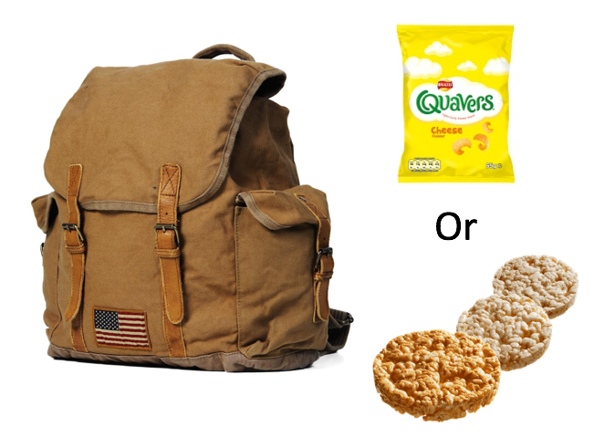

Method:

Step one: set up the apparatus below on a heat proof mat. Put 10 ml of water into a boiling tube, clamp the tube and record the temperature of the water in the table.
Step two: measure the mass of the rice cake. Record it in the table below.
GRAMS
Step three: light the Bunsen. Using a pair of tongs put the piece of rice cake into the roaring blue flame until it catches fire.
1
2
Step four: return the Bunsen to the safety flame. Hold the food just underneath the boiling tube so that it warms the water. When the food stops burning place it into a beaker of water to prevent it from filling the room with smoke. Repeat the experiment according to the results table below.

2. ………………
3. ………………
4. ………………
1. ………………
5. ………………
7. ………………
8. ………………
6. ………………
9. ………………
4
5

Results:

Rice cake repeat | Mass  (g) | Temperature of water before burning  (ºC) | Temperature of water after burning  (ºC) | Temperature rise  (ºC) | Temperature increase per gram of food  (ºC /g)
1
2
3
Average

Quaver repeat | Mass  (g) | Temperature of water before burning  (ºC) | Temperature of water after burning  (ºC) | Temperature rise  (ºC) | Temperature increase per gram of food  (ºC /g)
1
2
3
Average

Questions:

- Did the rice cake or quaver transfer the most energy to the water? How do you know?

- Look at the packets for these foods, does your experimental result agree with the information on the packet? If they don’t agree, why not? Think about how energy is transferred from the food to the water.

- If you were climbing a mountain, would you rather take rice cakes or quavers in your backpack? Use your results to justify your reasoning.

Progress: further resources are available here https://www.thescienceteacher.co.uk/

