Topic | Circulatory system | Level | Key Stage 4 (or any course for students aged 14-16)
Outcomes | To be able to relate the structure and function of:  - Veins  - Arteries  - Heart  - Capillaries  To suggest what structural adaptations might be present in a mammal with high blood pressure.
Information for teachers | This activity explores students’ understanding of the circulatory system through the context of giraffes. The unfamiliar context requires students to really understand the function of vessels and the heart to answer this question and so provides a great setting to provide feedback.  The process of writing also provides an opportunity for students to structure and reorganise their own ideas to construct a deeper meaning. This resource should be used after students have learnt the structure and function of the heart and blood vessels and have received sentence level instruction in how to relate structure to function. Adaptations that could be suggested by students include:  - Larger heart with thicker muscular walls (7.5 cm thick) to generate a large pressure  - Faster heart rate (150 bpm) to generate higher pressure  - Thicker muscular walls of arteries to withstand high pressure  - Thick skin in the legs to withstand the higher pressure  - Valves inside the jugular vein to prevent blood from flowing back into the brain when the head is lowered  Make sure students complete the context map on page 2 before they start writing (this may need modelling with another example first) and there is a questionnaire on page 3 that you may want to use to explore the purpose and impact of writing in your classroom.
Other linked resources | Other resources on the heart and circulatory system are here:  http://thescienceteacher.co.uk/heart-and-circulatory-system/

The Circulatory System of Giraffes

Giraffes have a similar circulatory system to humans. Their bodies contain:
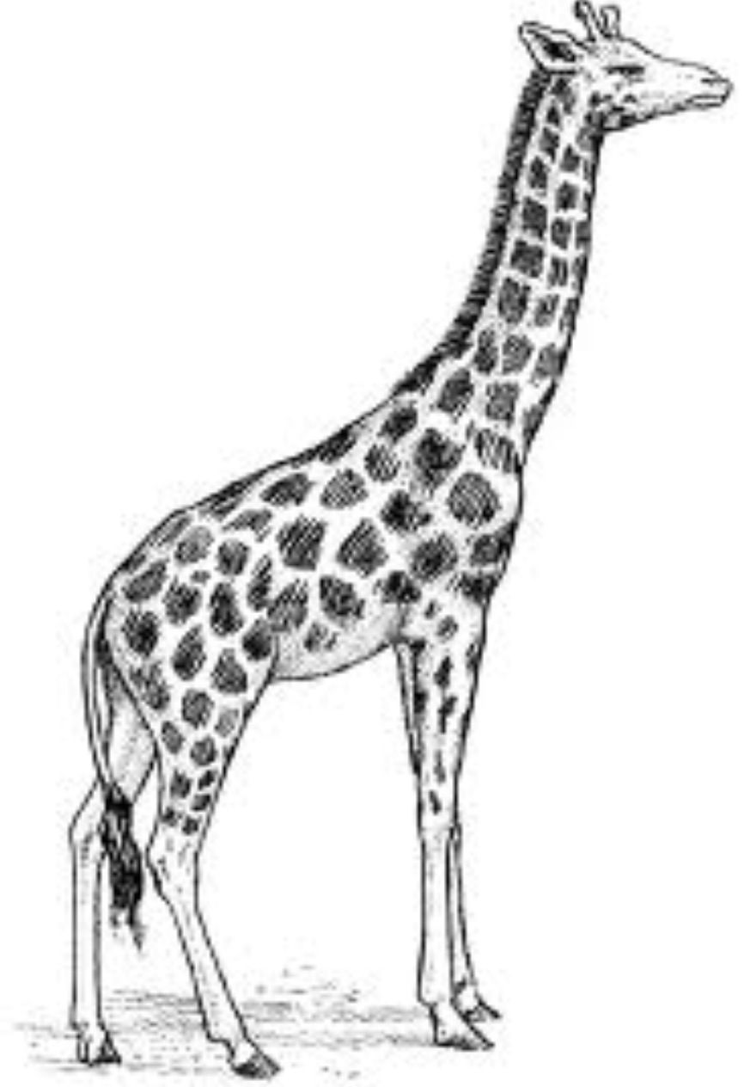
- arteries
- veins
- capillaries
- and a central heart with four chambers

However, unlike humans, giraffes must pump blood to the top of a very long neck. To achieve this, the blood pressure of giraffes is twice as high as ours.

Suggest and explain how the structure and function of the heart and blood vessels in humans and giraffes is similar and different.

You must refer to arteries, veins, capillaries and the heart in your answer.

Planning: Write down your ideas on this context map before you start writing to organise your thoughts. Connect related ideas with annotated lines.

Heart
Arteries

Circulatory system

Giraffes
Veins

mammals
that have

High blood pressure

Capillaries

Suggest and explain how the structure and function of the heart and blood vessels in humans and giraffes is similar and different.

You must refer to arteries, veins, capillaries and the heart in your answer.

Writing focus
Remember to link structure to function e.g. the post box is red to make it easier for people to see.

Writing

Please can you answer questions 1-4 before you receive feedback. Answer questions 5-6 after you have received feedback.

- I enjoyed thinking about this question.

Strongly disagree | Disagree | Undecided | Agree | Strongly Agree
1 | 2 | 3 | 4 | 5

- I enjoyed writing about this question.

Strongly disagree | Disagree | Undecided | Agree | Strongly Agree
1 | 2 | 3 | 4 | 5

- Writing about this question has helped me to organise my ideas better about the structure and function of the heart and blood vessels.

Strongly disagree | Disagree | Undecided | Agree | Strongly Agree
1 | 2 | 3 | 4 | 5

- Writing about this question has helped me to improve my understanding of the structure and function of the heart and blood vessels.

Strongly disagree | Disagree | Undecided | Agree | Strongly Agree
1 | 2 | 3 | 4 | 5

- The feedback from this writing task has helped me to improve my understanding of the structure and function of the heart and blood vessels.

Strongly disagree | Disagree | Undecided | Agree | Strongly Agree
1 | 2 | 3 | 4 | 5

- I will be more likely to remember the correct facts about the heart and blood vessels because I did this piece of writing.

Strongly disagree | Disagree | Undecided | Agree | Strongly Agree
1 | 2 | 3 | 4 | 5

