Topic | Nuclear fission | Level | Key Stage 4 (or any course for students aged 14-16)
Outcomes | - Explain the process of nuclear fission  - Appreciate the destructive role that science and scientists can have on human civilisation
Information for teachers | This two-page summary explains the science behind nuclear fission in the context of the atomic bomb dropped on Hiroshima in 1945. The context provides an opportunity for students to consider the role scientific ‘progress’ plays on human lives. Before teaching nuclear fission make sure students are confident with the different types of radioactive decay and atomic structure.  The majority of information below has been taken from “An Introduction to the Atomic Bomb Tragedy” by the Hiroshima Peace Memorial Museum.

Hiroshima and the Atomic Bomb Tragedy

The first use of an atomic bomb against humans

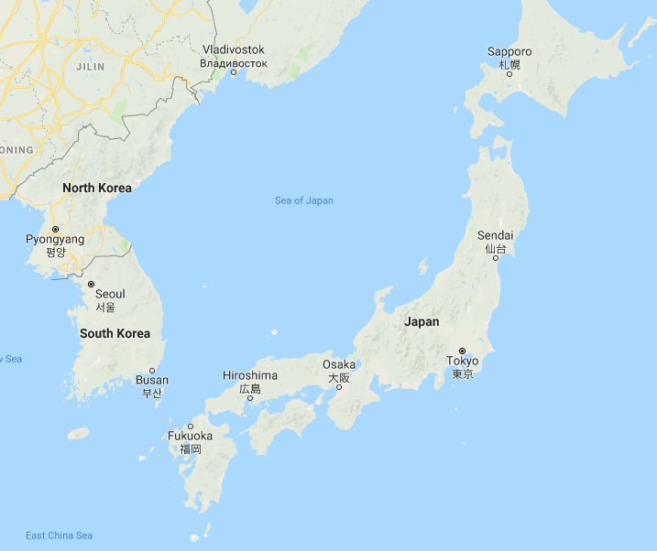
At 1:45 a.m. on August 6th, 1945, an American bomber departed from Tinian
Island and headed to Hiroshima, Japan. At 8.15 a.m. the first atomic bomb to be used against human beings was dropped over central Hiroshima. The bomb caused fierce heat and radiation to burst out in every direction. Temperatures on the ground reached 3,000-4,000 ºC with people suffering burns as far as 3.5 km away from the blast. It was so hot that coins melted and internal organs boiled.
Figure 1 Location of Hiroshima in Japan

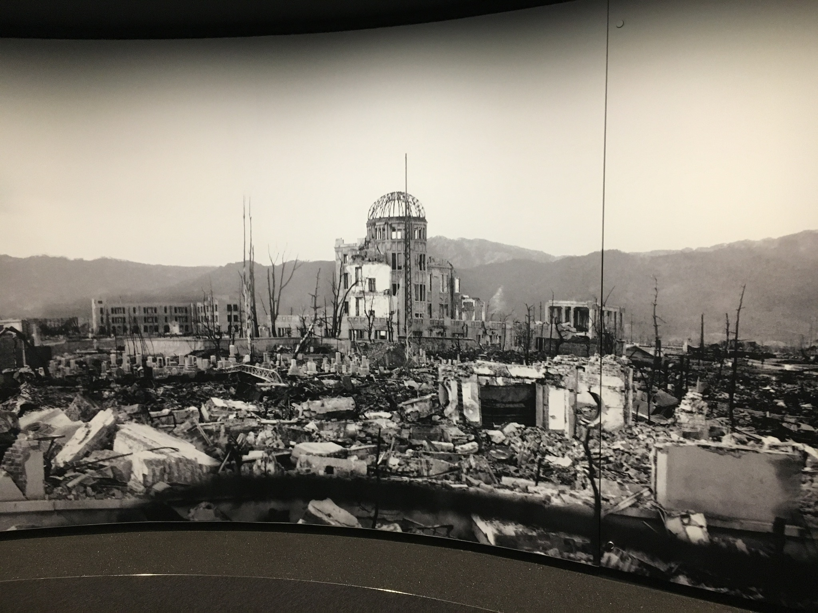
Approximately 350,000 people were believed to be in Hiroshima when the bomb exploded. Estimates suggest that by the end of December 1945, 140,000 people had died with 90% of the buildings having burned or collapsed. Of the energy emitted during the explosion, approximately 50% was in the form of the blast, 35 % was through heat and 15% was radiation. A further atomic bomb was dropped on Nagasaki on August 9th and on August 15th Japan surrendered.
Figure 2 Hiroshima after the blast

Making of the atomic bomb

In 1942 the American president, Franklin Delano Roosevelt, approved the development of both a uranium and a plutonium atomic bomb. There was a fear that Germany was already developing these types of weapons. The project was known as the Manhattan Project and by the end of 1945, approximately $2 billion dollars had been invested on developing the weapons. The project produced one uranium and two plutonium bombs. On July 1945, one of the plutonium bombs was tested in the desert near Alamogordo, New Mexico. It was the world’s first atomic bomb test and was a success.

How does an atomic bomb work?

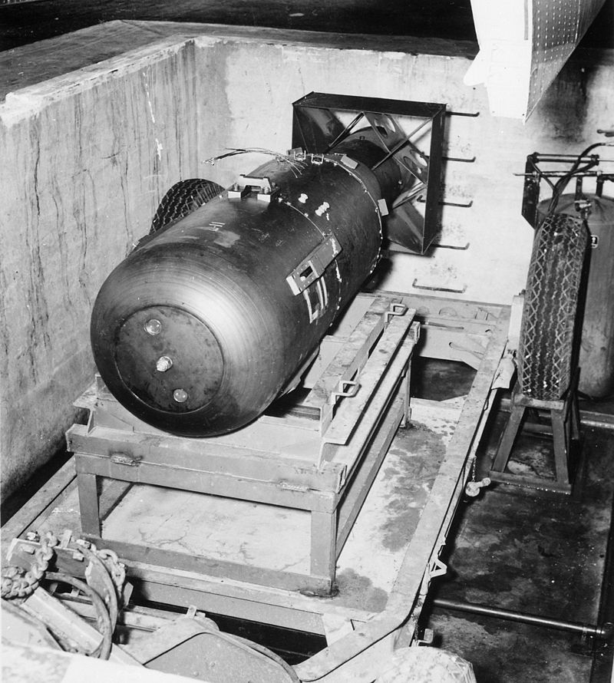
The atomic bomb dropped on Hiroshima was called Little Boy. The total energy released by Little Boy was equivalent to 16 thousand tonnes of TNT.
Figure 3 Little Boy - the name of the atomic bomb dropped on Hiroshima

The energy from the blast came from a process called nuclear fission. The fissionable material used was uranium 235. When a neutron strikes a uranium 235 nucleus the nucleus absorbs the neutron, shakes violently and constricts at the centre. The positively charged protons repel each other and the nucleus then splits into two smaller nuclei, forming radioactive elements and releases two or three neutrons and some gamma radiation. All the fissionable products have kinetic energy. Some of these neutrons will be absorbed by other ²³⁵U nuclei causing further fission to take place.

Although products of fission vary, in a typical ²³⁵U fission event a ²³⁵U nucleus absorbs a neutron producing ²³⁶U in a highly excited state. It is this nucleus that then undergoes fission, splitting typically into ¹⁴⁰Xe and ⁹⁴Sr. We can write a stepwise fission equation to show this:

²³⁵U + n ²³⁶U ¹⁴⁰Xe + ⁹⁴Sr + 2n

¹⁴⁰Xe and ⁹⁴Sr are highly unstable and undergo beta decay.

Radiation

The radiation emitted one minute after the explosion was lethal within 1 km of the hypocentre with most people dying within a few days. Symptoms from the blast included hair loss, insomnia, vomiting and blood in urine. Most of these effects were caused by high does of radiation killing human cells. At the end of December the acute effects of the bomb were mostly over and so people believed the harmful effects of radiation were finished. However, from 1950 the number of cases of leukaemia and cancer soared as a result of radiation-induced mutations.

Questions:

- Produce a timeline to show the key events involving the atomic bomb and its use in Japan, start with 1942 – creation of the Manhattan Project.
- Uranium has two primary isotopes, ²³⁸U and ²³⁵U, normally appearing in the ratio of 99.3% to 0.7% respectively. Explain how the nuclei of these atoms are similar and different.
- Sketch a diagram to show the steps that take place when a uranium nucleus absorbs a neutron.
- Suggest why a neutron and not a proton is used to start nuclear fission.
- The radioactivity of ²³⁵U is very low. Explain then why the people of Hiroshima were exposed to high levels of radiation after the atomic bomb was dropped.
- What is the difference between radioactive decay and a nuclear reaction?
- Nuclear fission is an example of a chain reaction. Explain what is meant by a chain reaction and suggest one way in which this reaction could be slowed.
- After the bombing, the Japanese government dispatched a number of teams to enter Hiroshima to identify what had caused the explosion. Explain how they could have confirmed that the blast was caused by an atomic bomb?
- Nuclear fission releases huge amounts of energy from large and unstable nuclei. Compare how this process is similar and different to the combustion of coal.
- To what extent were the scientists from the Manhattan Project, as opposed to politicians, responsible for the destruction that took place in Hiroshima?

Progress: further resources on physics are available here: http://thescienceteacher.co.uk/physics-teaching-resources/

