Topic | Drug discovery - penicillin | Level | GCSE (or any other course for students aged 11-16)
Outcomes | - Describe how Alexander Fleming discovered penicillin.  - Describe the advantages of using synthetic forms of drugs rather than using extracts from organisms.
Information for teachers | Students should already understand what bacteria and fungi are and know how these organisms can be grown in the lab. This activity provides an opportunity for students to apply their knowledge of drug discovery to penicillin.

The discovery of penicillin – did Fleming just get lucky?!
In 1928 Alexander Fleming was growing some bacteria on agar plates. He went on holiday and returned to find that some of his agar plates had been contaminated with mould. Here is an image of what Alexander Fleming might have seen.
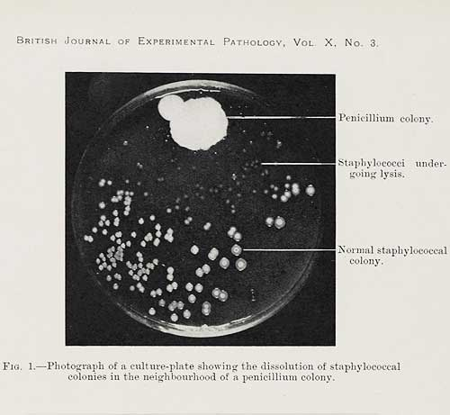
Use the picture above to answer the following questions:
- What did Fleming notice about the bacteria colonies near the mould?
- What did this suggest about the mould?
- How can we tell from the picture that the antibiotic was a chemical that could diffuse through the agar?
- Why was the antibiotic named penicillin?
- Fleming grew this mould in some liquid culture. It proved lethal for other bacteria. What important information did this tell him?
- Describe and explain what the agar plate would have looked like if the bacteria were resistant to penicillin.
- Two scientists called Howard Florey and Ernst Chain discovered a way to extract and produce penicillin on an industrial scale. This was used to supply the demands of World War II. Today, many forms of antibiotics come from synthetic forms. Suggest two advantages of synthesising penicillin as opposed to extracting it from fungi.
- Fleming was awarded a Nobel prize for medicine for his discovery. Was this award justified or did he just get lucky?! Explain your answer by reference to his work.

