Topic | Electromagnetic waves | Level | GCSE (or any course for students aged 11-16)
Outcomes | - To describe some uses for electromagnetic waves  - To understand that different substances may absorb, transmit, refract or reflect electromagnetic waves in ways that vary with wavelength
Information for teachers | The first part of the worksheet is suitable to use at the beginning of the topic. The questions on page 2 are much more challenging. Use these questions later on to diagnose whether knowledge of EM waves has been learnt and understood. These questions will hopefully help students to make meaning by challenging superficial thinking.

Electromagnetic waves

Fundamental ideas

- What is the primary source of Earth’s electromagnetic radiation?
- What type of waves are electromagnetic waves?
- Microwaves have a higher frequency than radio waves so why don’t they travel faster?
- What speed do electromagnetic waves travel at?
- Complete the table below on the practical uses of electromagnetic waves.

Practical application | Object that uses the EM spectrum | Region of the EM spectrum used
Fire fighters need to be able to see through smoke to find people and identify hot spots | Infrared cameras | Infrared
To sterilise medical equipment used in operations. | N.A.
Vipers, pythons and boas have holes on their faces called pit organs, which contain a membrane that can detect infrared radiation from warm bodies up to one metre away.
 | Microwave
Sun tanning before a holiday
 |  | Visible light
 | TV remote control
 | X-ray machine

Time to get thinking!

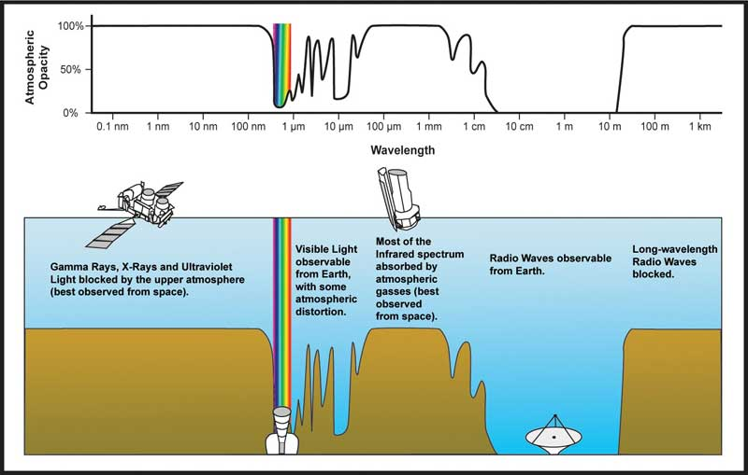
Source: http://invaderxan.pbworks.com/f/1193264846/atmospheric-opacity.jpg

- If our eyes evolved to ‘see’ radio waves would they be bigger or smaller than our eyes today? Explain your answer.
- Why are the only two types of telescope on Earth using radio waves and visible light?
- Why do you think our eyes evolved to see visible light and not other regions of the electromagnetic spectrum?
- “The electromagnetic spectrum is just light that you cannot see.” Do you agree or disagree with this statement? Explain your answer.
- Why can’t our watery eyes see IR radiation?
- Why was life restricted to the ocean before the ozone layer was formed 600 million years ago?
- Radio and gamma waves can travel through brick walls. Why can’t visible light travel through a brick wall?

