Topic | Precise, Accurate, Repeatable and Reproducible | Level | GCSE (or any course for students aged 11-16)
Outcomes | To explain the difference between precise and accurate  To explain the difference between repeatable and reproducible.

Has Daisy got a temperature?
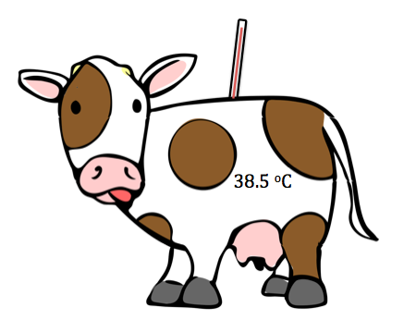

Farmer Nick had a beautiful cow called Daisy. One day Daisy felt rather hot. He wanted to measure Daisy’s temperature. He put a thermometer onto Daisy's skin and recorded the temperature. He repeated his measurement three more times using the same thermometer and recorded the temperatures below:

Reading number | Temperature (ºC)
1 | 35
2 | 37
3 | 36
4 | 36
Mean | 36

- Was Nick accurate? Use the picture of Daisy to explain your answer.

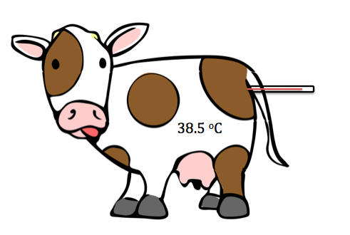
Farmer Jim's daughter, Amy, decided that a better way to take the temperature was to use a rectal thermometer.

Reading number | Temperature (ºC) measured by Amy
1 | 42.0
2 | 37.0
3 | 39.0
4 | 36.0
Mean | 38.5

- Was Amy accurate? Use the picture of Daisy to explain your answer.

Here are the reading made by both farmer Nick and Amy.

Reading number | Temperature (ºC) measured by Nick | Temperature (ºC) measured by Amy
1 | 35 | 42.0
2 | 37 | 37.0
3 | 36 | 39.0
4 | 36 | 36.0
Mean | 36 | 38.5

Mark onto the thermometers the temperatures recorded by Nick and Amy.

Farmer Nick’s readings Amy’s readings

- Use the thermometers above to explain who collected the most precise results.

- Did Nick and Amy get reproducible results? Explain your answer.

- Did Nick or Amy get repeatable results? Explain your answer.

Progress: further resources on working scientifically are available here:
http://thescienceteacher.co.uk/how-science-works/

