Topic | Human reproduction | Level | GCSE and Key Stage 3 (or any course for students aged 11-16)
Outcomes | To describes the main stages of reproduction in humans: fertilisation, implantation, growth and birth  To know that some contraceptive pills prevent ovulation  To describe and explain the changes to the lining of the uterus during pregnancy and menstruation

Instructions for teachers – print page 2 in A3. The idea behind this activity is that students get a clear understanding of how the stages of reproduction link together. Students are probably best to be grouped in pairs or threes. Give each group a dice and each player a counter. Students take turns to roll the dice. They will either move onto the next square or not depending on what number they roll. Once they move that is the end of their go and it is then the turn of the next player. The winner is the person who cuts the umbilical cord first!

The reproduction roulette! Who will cut the umbilical cord first?!

7. Implantation | 8. Growth of foetus | 9. Birth
After 6 to 7 days the embryo moves into the uterus.  - Throw a 1,2,3,4 or 5 for implantation to occur and move on one square.  - Throw a 6 and implantation fails. Return to 1. | After 8 weeks of growth the embryo is called a foetus and resembles a baby.  - Throw a 1,2,3,4 or 5 for the embryo to grow a placenta and move on one square. | After about 40 weeks the baby is born.  - Throw a 1,3 or 5 to push out the placenta, cut the umbilical cord and move on one square.  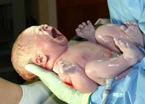 | The End
6. Embryo is formed | 5. Fertilisation | 4. Ejaculation
6. Embryo is formed  After 12 hours the fertilised egg cell divides by mitosis in the oviduct into a ball of cells that will form the embryo.  - Throw a 1,2,3 or 4 and move on one square.  - Throw a 5 or 6 for the embryo to die. Return to 1. | Sperm reach the egg.  - Throw a 4,5 or 6 for the sperm to fertilise the egg and move on one square.  - Throw a 1,2 or 3 for the sperm to not fertilise the egg. Return to 1. | During sexual intercourse sperm are released into the vagina from the penis. This is called ejaculation.  - Throw a 1,2 or 3 for sperm to reach the egg and move on one square.  - Throw a 4,5 or 6 for all sperm to die on their journey. You must throw a 6 to move on.
1. The period starts | 2. Uterus lining thickens | 3. An egg is released
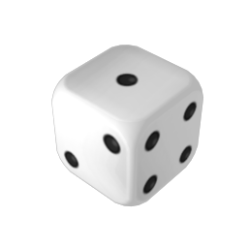  START  Blood from the lining of the uterus leaves the body through the vagina. This is called a period. This will last between 3 - 7 days.  - Throw a 1,2,3,4 or 5 for the period to stop and move on one square. | The lining of the uterus begins to re-grow and becomes thicker.  - Throw a 1,3 or 5 for the uterus lining to be repaired and move on one square. | An egg develops in the ovary.  - Throw a 1,2,3,4 or 5 for the egg to be released into the oviduct and move on one square.  - Throw a 6 and the egg won’t be released as the contraceptive pill has stopped ovulation. Return to 1.

