Topic | Structure and function of human lungs | Level | GCSE (or any other course for students aged 11-16)
Outcomes | - To label the structure of the lungs  - To describe and explain the function of each structure

Structure of the breathing system - reading activity

1. Use the diagram to fill in the missing spaces in the text below.
2. Use the text to annotate the diagram with notes on each structure.
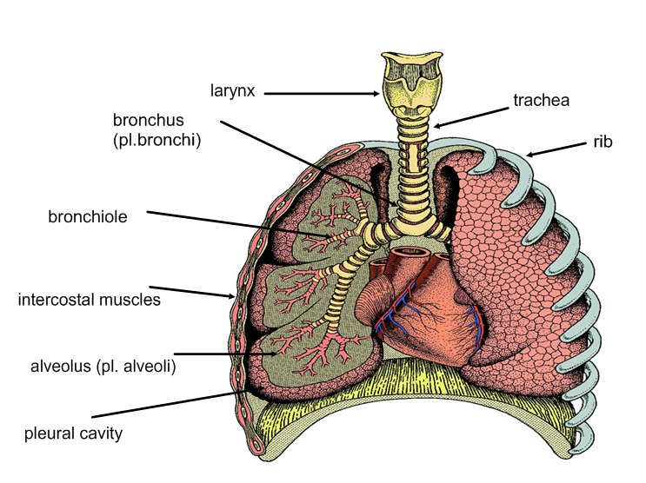
diaphragm

After flowing through the ____________ (voice box), air passes through the __________ (windpipe), which is made of rings of tough cartilage. The __________ then branches into two ____________, which branch further to form ____________. These end up at tiny air sacs called __________, where gas exchange takes place. The lungs are surrounded by a _______ ________, which makes a slippery fluid.

Your lungs are protected by bones called _______. These move during breathing, and this movement is brought about by the action of _____________ _____________, which lie between the ribs. The ______________ is a muscle that forms the floor of the thorax, and it also moves during breathing.

