Topic | Repeatability and reproducibility | Level | GCSE/KS3 (or any course for students aged 11-16)
Outcomes | - To understand the term repeatable  - To carry out an experiment to find out which scientists has the most repeatable results?  - To know the difference between repeatability and reproducibility

How repeatable are my results?

What do we mean then by a repeatable measurement? Scientists often want to repeat a measurement to see if they get the same result, if we do get the same (or similar) results then we can be more confident in our conclusion.

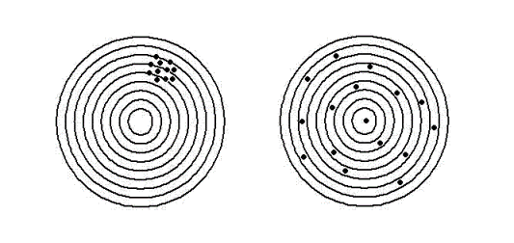
If a scientist repeats an experiment and gets a similar result then we say the results are repeatable. The image below will help you to understand this further.

Aim: to see who in the class can get the most repeatable results.
Figure 1 The image on the left shows repeatable measurements as all the values are similar. The image on the right shows measurements that are not repeatable because the values are different from each other.

Method

1. Place 10 cm³ of 0.5 mol/dm³ HCl into a boiling tube using a measuring cylinder
2. Record the initial temperature of the acid to the nearest 0.5 ºC. Make sure you give enough time for the temperature to change
3. Add the Mg piece(s)
4. Record the highest temperature of the acid to the nearest 0.5 ºC
5. Repeat the experiment twice more with clean boiling tubes
6. Now repeat steps 1-5 but this time use two and three pieces of magnesium

 | Initial Temp.  (ºC) |  |  |  | Highest Temp.  (ºC) |  |  | Temp Change  (ºC)
 | Exp.1 | Exp.2 | Exp.3 | Exp.1 |  | Exp.2 | Exp.3 | Exp.1 | Exp.2 | Exp.3
1 piece of Mg
2 pieces of Mg
3 pieces of Mg

- Draw a line graph of your results, showing the temperature change for each repeat against the number of Mg pieces. Do not take an average. Make sure it takes up ¾ of the graph paper. Add a title and label the axes.
- Explain what the term repeatable means.
- Were your measurements repeatable? Explain your answer using your graph.
- Which experiment had the most repeatable results (with 1,2 or 3 pieces of Mg)? Explain your answer.
- Which experiment had the least repeatable results (with 1,2 or 3 pieces of Mg)? Explain your answer.
- Describe the relationship shown by your graph.
- List the variables you kept the same between each repeat experiment.
- What changes would you make to the method to increase the repeatability of your experiment?
- Compare your results to other members in your class. Are they reproducible?

