Topic | Free body diagrams | Level | GCSE (or any other course for students aged 11-16)
Outcomes | - To draw accurate free body diagrams for a series of different situations involving multiple forces

Fold the sheet in half along the line. Draw the free body diagram and then check to see you got it right.

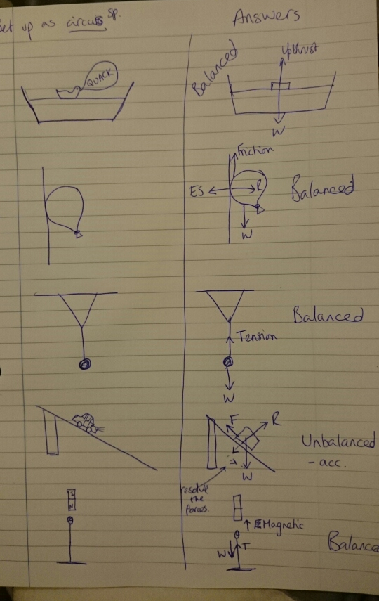

Progress: further resources on forces are available here: http://www.thescienceteacher.co.uk/forces

