Topic | Pressure, force and area | Level | GCSE (or any other course for students aged 11-16)
Outcomes | - To measure the area of an irregular object  - To calculate the area of a circle  - To use and understand the equation p=f/a

Reducing the pressure: Heel Stoppers

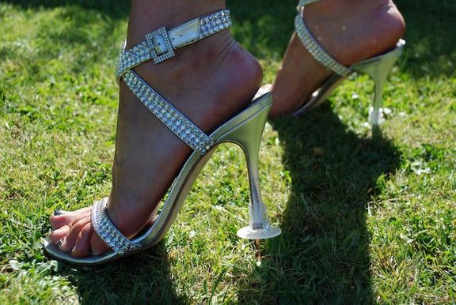
Brief: You are working for a company called Clean Heels Limited. You have been asked to carry out some calculations to show how effective their new Heel Stoppers are. First watch this clip: https://www.youtube.com/watch?v=s2d6Rzq0N1Q

Calculations: In the video above, Deborah Meaden says the Heel Stoppers make “a lot of difference”. How much difference do they make?

- Calculate the surface area of the high heel shoe you have been given using 1cm² paper.

- Now calculate the surface area of the high heel shoe, assuming that it now has the Heel Stopper connected, with a surface area of 2.5 cm².

- Using your answers to questions 1 and 2 you now need to perform some calculations to show why the Heel Stoppers are effective at reducing the total pressure exerted on the ground by the shoes? You can assume that the average mass of the customer is 70.2 kg.

- Some of the Heel Stoppers are embellished with pearls and diamonds (see below). Why might this reduce the effectiveness of the Heel Stopper? Do you think this is a significant problem? Perform a calculation to support your answer; you will need to make some assumptions.

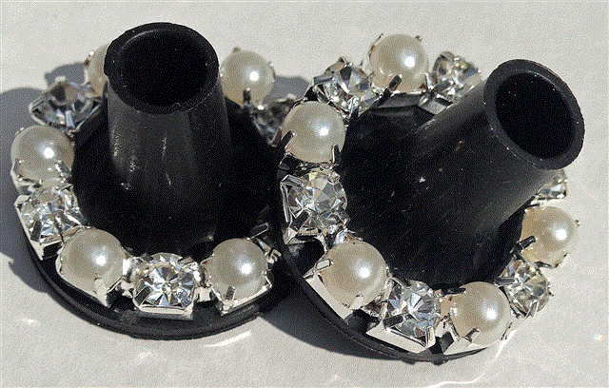

Progress: further resources on forces are available here: http://www.thescienceteacher.co.uk/forces

