Topic | Percentage yield | Level | GCSE (or any course for students aged 11-16)
Outcomes | - To carry out an experiment to make MgO and calculate percentage yield and record results in a suitable table  - To understand why experiments do not always produce a percentage yield of 100%  - To consider the importance of percentage yield to an industrial chemist

Synthesis of magnesium oxide and calculation of percentage yield

percentage yield = (actual yield / theoretical yield) x 100

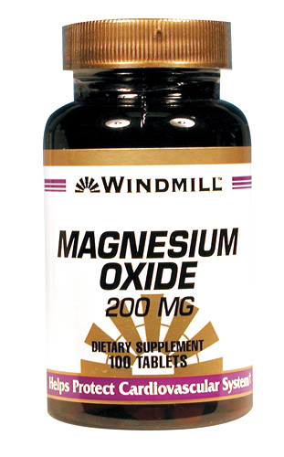
Background: In an ideal world, when you carry out a chemical reaction the percentage yield would be 100% i.e. all the reactants would react to produce your product, and none of the product would be lost during the synthesis. However, most reactions do not result in a 100% yield. Today we are going to work out the percentage yield for the synthesis of magnesium oxide.

Magnesium oxide can be used in the treatment of heartburn. You are going to imagine that you are a research chemist working for a pharmaceutical company that is interested in the reaction below. You are going to work out the percentage yield of the reaction below to see if this is a viable way for your company to make magnesium oxide.

Aim: to prepare MgO, calculate the percentage yield and evaluate the method of preparation.

2 Mg + O₂ 2 MgO

Before you begin the experiment you will need to produce a results table for your results. Read the method below and then draw a suitable results table in this box.

Method:
- Sand paper the Mg ribbon.
- Coil the ribbon around a pencil.
- Weigh an empty crucible and record the mass. Add Mg and reweigh. Record the new mass. Work out the mass of the Mg used and record in your table.
- Set up the apparatus as shown below.
- Heat the magnesium ribbon and every so often lift the lid using the tongs to let more air in. DO NOT LOOK DIRECTLY AT THE FLAME.
- When the reaction is complete let the apparatus cool.
- Re-weigh the crucible. What is the mass of the magnesium oxide that was formed?

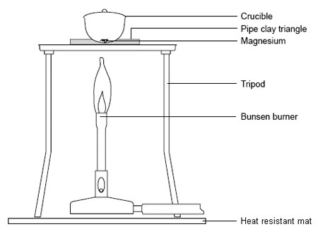

Complete the table below:

Step in method | Why?
Sand paper the Mg ribbon.

Coil the ribbon around a pencil.
Heat the magnesium ribbon and every so often lift the lid of the crucible.

Questions:

- What was the actual yield of MgO made in your experiment?
- Calculate the percentage yield for your synthesis.
- Why is the percentage yield not 100%? How could you carry out the experiment differently to improve your percentage yield?
- Do you consider this reaction to be a good way for your company to prepare MgO? Explain with reference to the percentage yield, costs of reactants and method of preparation whether you would recommend this method to make MgO on a large scale.
- One problem with this method is that magnesium nitride is also formed. How does this affect your percentage yield calculated in questions 3?

