Topic | Balancing equations | Level | GCSE (or any course for students aged 11-16)
Outcomes | - To understand why chemists balance equations  - To balance simple chemical equations

How to balance chemical equations: a new approach

Below you are going to understand how to balance chemical equations. We are going to start with some simple examples first and then work up from there.
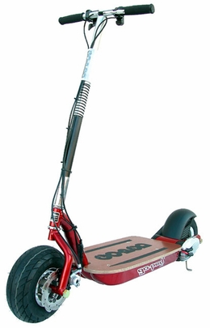

Which equation is the odd one out and why?

1. frame + wheel + wheel scooter
2. mouth + nose + eye face
3. board + wheel skate board

The answer is equation one. This is because this is the only equation that is balanced, i.e. both the left hand side and the right hand side contain the same number of parts: a frame and 2 wheels, it is just on the right hand side these are combined to make a scooter. Equation two is not balanced because a face has two eyes; to correct this:

mouth + nose + eye + eye face (Ah, much better! )

We could represent this equation more simply by:

mouth + nose + 2 eye face

Note that we can only balance equations by changing the number of each part, we cannot change what the part is. We can assume there is a 1 in front of any part in an equation but for simplicity we don’t usually write this:

1 mouth + 1 nose + 2 eye 1 face is written as mouth + nose + 2 eye face

Try to balance the equations below:

- ? frame + ? wheel 2 bike
- ? frame + ? wheel 4 bike
- ? tyre + ? steering wheel + ? body car
- 1 tricycle ? tyre + ? steering wheel + ? frame
- hand ? finger + ? thumb
- 4 hand ? finger + ? thumb
- centipede ? leg + ? head
- ? proton + ? neutron + ? electron lithium atom
- Big Mac
- ? proton + electron

Now that you have mastered balancing these equations, let's have a think about the equation we started with

frame + 2 wheel scooter

THINK! What can we say about the mass of the left hand side and right hand side of this equation?

Hopefully you can see that the mass of both sides of the equation will be identical. This is one of the most important points to remember when we move on to chemical examples.
Figure 1 The mass of the left hand side (reactants) will equal the mass of the right hand side (products) if our equation is balanced
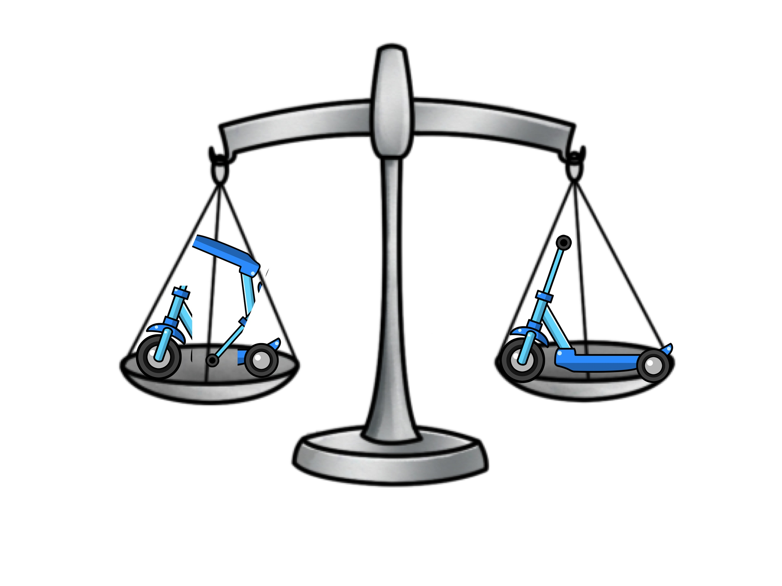

Now, using the same logic as we have used above we can balance chemical equations. This will make sure there are the same number of atoms on both sides of the equation. Remember, you can only do this by changing the number of parts, not what that the part is. For example look at the equation below:

O₂ + H₂ H₂O

The unbalanced equation tells us that one oxygen molecule reacts with one hydrogen molecule to make one water molecule. There are two oxygen atoms on the left side and only one oxygen atom on the right side. We can't simply balance the atoms by doing this.

O₂ + H₂ H₂O₂ NO NO!!

Why not? The reason is you are changing what the part is, you have changed the product from water (H₂O) to hydrogen peroxide (H₂O₂). This is equivalent in our examples at the start of changing a wheel to an apple.

So, how can we balance the equation? The method is exactly the same as earlier. Firstly, we balance the oxygen atoms by adding 2 parts (or molecules) of water. In step 2 we then have to balance the hydrogen atoms.

Step 1 to balance oxygen atoms: O₂ + H₂ 2 H₂O

Step 2 to balance hydrogen atoms: O₂ + 2 H₂ 2H₂O

Have a go at these:

- Na + Cl₂ NaCl
- Ca + O₂ CaO
- H₂ + Cl₂ HCl
- C + H₂ CH₄
- Al + Cl₂ AlCl₃
- KBr + F₂ KF + Br₂
- NaI + Br₂ NaBr + I₂
- CH₄ + O₂ CO₂ + H₂O
- H₂SO₄ + NaOH Na₂SO₄ + H₂O
- C₃H₈ + O₂ CO₂ + H₂O

Hopefully you can now balance chemical equations. My top tip when dealing with more complicated ones is to work from left to right along the equation, always balancing diatomic molecules at the end! Good luck.

Progress: further resources on amounts of substance are available here http://www.thescienceteacher.co.uk/moles/

