Topic | Plant cell structure | Level | Key Stage 3 (or any other course for students aged 11-14).
Outcomes | - To describe the function of plant cell organelles  This resource was contributed by Jane Masters (@mrsjmasters). View Jane’s blog at https://pedagoggles.wordpress.com/

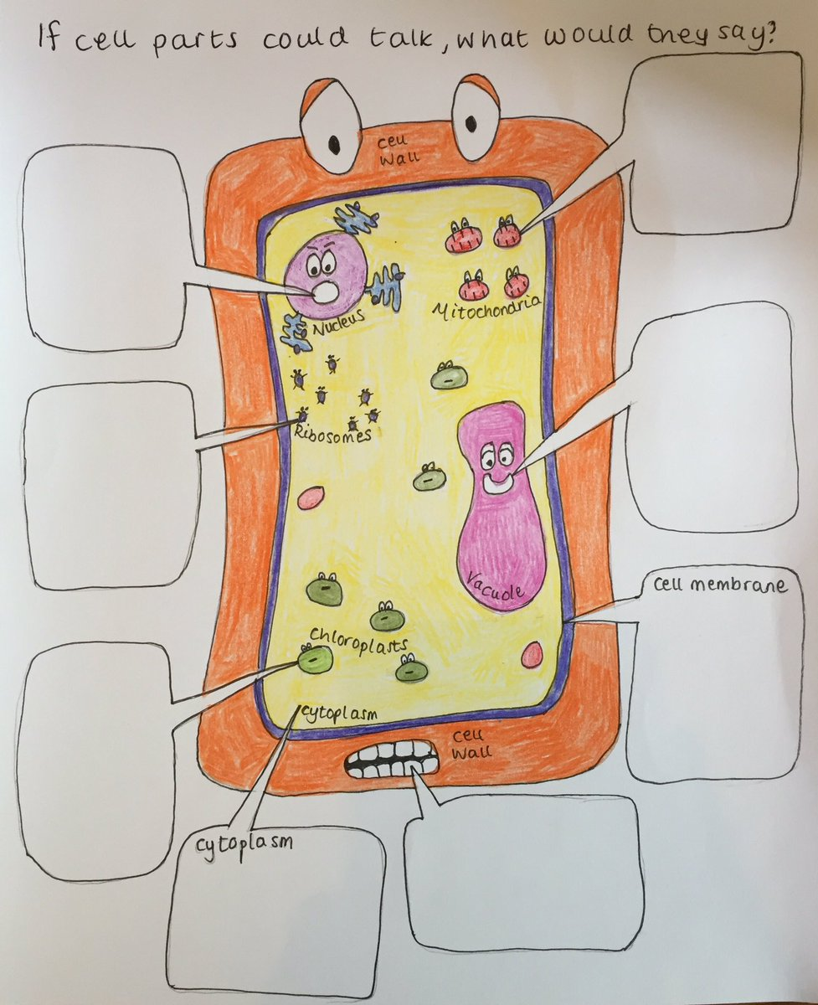

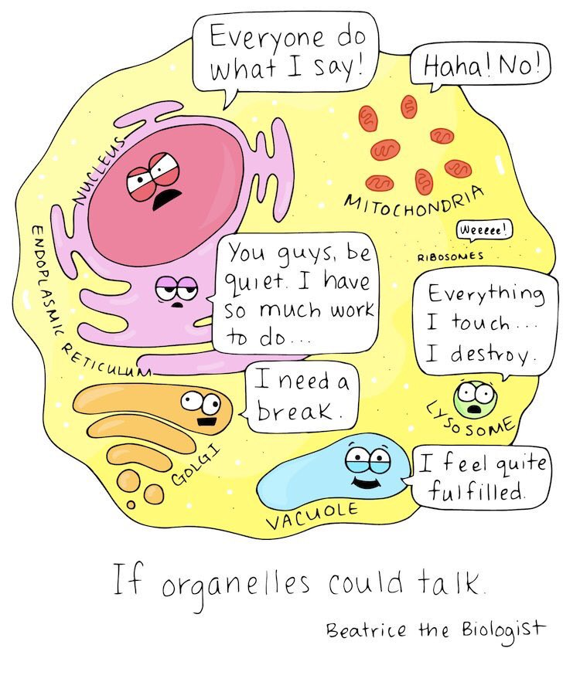

Image from http://www.beatricebiologist.com/

Progress: further resources on cells are available here: http://thescienceteacher.co.uk/cells/

