Topic | Reactions of acids | Level | GCSE (or any course for students aged 11-16)
Outcomes | To plan and carry out an investigation to identify metal carbonates, metals, metal hydroxides and metal oxides using reactions of acids.

Reactions of acids: you investigate!
The Challenge
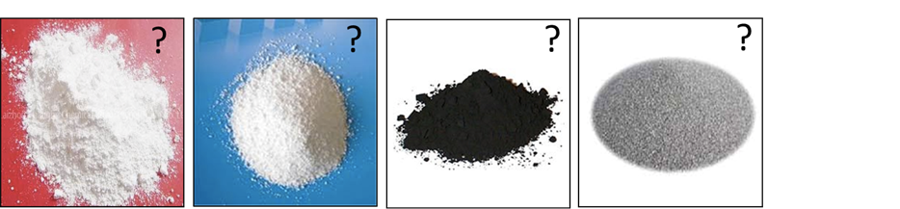
You have been given four different solid substances labelled A,B,C and D. You need to use your knowledge of reactions of acids to carry out some chemical tests to identify which substance is:
- Sodium carbonate
- Magnesium powder
- Copper (II) oxide
- Magnesium hydroxide

Brainstorm
Substance | Products made when the substance reacts with HCl | How could you test for these products?
Sodium carbonate
Magnesium
Copper (II) oxide
Magnesium hydroxide
Before you begin the experiment, you need to think about what products are made when acids react with the four substances in the table below.
Reagents and apparatus you can use

- Universal indicator solution
- Limewater
- Water
- Hydrochloric acid 0.5 mol/dm³
- Splint and access to a flame
- A night light
- Delivery tube
- Test tubes

Safety
Wear goggles throughout. HCl is an irritant, CuO and Na₂CO₃ are harmful, Mg and universal indicator are highly flammable.
Results
Substance | A, B, C or D | Evidence for your prediction (what chemical test did you use and what was the result?)
Sodium carbonate
Magnesium
Copper (II) oxide
Magnesium hydroxide

Questions
- Write balanced word equations for each substance reacting with hydrochloric acid.
- Make a yes or no diagram that a chemist could use to work out if an unknown substance is a metal, metal carbonate, base or alkali.

