Topic | Planning science lessons – blank template | Level | Various
Outcomes | To provide a framework to support teachers to plan science lessons.

EPIBA: a simple approach to support lesson planning in science

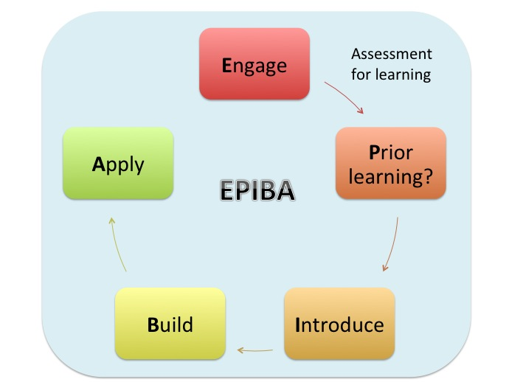

Progress: further resources on teaching and learning are available at http://www.thescienceteacher.co.uk/teaching-and-learning.
Assessment | EPIBA | What? | Why? | Time  (min) | Example
Assessment for learning should run throughout  *looking at student work  *questioning  * mini-white boards  *peer assessment  Assessment for learning should run throughout  *looking at student work  *questioning  * mini-white boards  *peer assessment | E | Engage (often the Do it Now) | Motivate students – provide them with an opportunity to succeed as soon as they enter the classroom and recap/consolidate key knowledge from the previous lesson. | 3-5
Introduce learning objective–

Key words:
 | Knowledge outcomes: |  |  | Skills outcomes:
 | P | Prior learning check and set-up | Check misconceptions and assess prior knowledge so that the rest of the lesson can be pitched correctly. | 10
 | I | Introduce new knowledge | Introduce new knowledge. Begin with a concrete idea or simple context so that you start from what your students already know. Modelling is important here. | 10
 | B | Build new content | Students have the opportunity to practice what they have learnt in the introduce section to consolidate learning and develop understanding. | 15
 | A | Apply new content | Students have the opportunity to apply what they have learnt to new situations. This will assess understanding and consolidate understanding. | 15

