Topic | Planning science lessons | Level | Various
Outcomes | To provide a framework to support teachers to plan science lessons.

EPIBA: a simple approach to support lesson planning in science

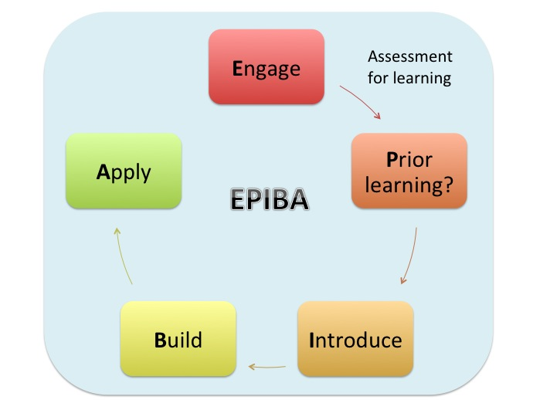

Progress: further resources on teaching and learning are available at http://www.thescienceteacher.co.uk/teaching-and-learning.
Assessment | EPIBA | What? | Why? | Time  (min) | Example
Assessment for learning should run throughout  *looking at student work  *questioning  * mini-white boards  *peer assessment  Assessment for learning should run throughout  *looking at student work  *questioning  * mini-white boards  *peer assessment | E | Engage (often the Do it Now) | Motivate students – provide them with an opportunity to succeed as soon as they enter the classroom and recap/consolidate key knowledge from the previous lesson. | 3-5 | Students enter the room and there are three pictures on the board: salt, sand and sugar. They must identify the odd one out and explain why. The task is open so success is for all and builds in difficulty. Teacher reviews answers. Sand won’t dissolve is where we are heading.
Introduce learning objective– today we are going to understand what happens to a solid when it dissolves.
Key words: particle, dissolve, solution, solute, solvent, suspension, model
 | Knowledge outcomes:  - to use and understand the terms solute, solvent, suspension and solution  - to give an example of each  - to draw labelled particle pictures to describe and explain what happens when a solute dissolves. |  |  | Skills outcomes:  - to use a model to describe a process that cannot be observed
 | P | Prior learning check and set-up | Check misconceptions and assess prior knowledge so that the rest of the lesson can be pitched correctly. | 10 | A practical demonstration is used to show salt being added to water in a large beaker. In pairs students use a concept cartoon to discuss what is happening to the mass of the water. This is discussed in pairs and then as a whole class.
 | I | Introduce new knowledge | Introduce new knowledge. Begin with a concrete idea or simple context so that you start from what your students already know. Modelling is important here. | 10 | The teacher does direct instruction using the white board to draw a particle picture to show what is happening to the solute and solvent particles during dissolving. A computer PHET model is also used to support the teacher explanation.
 | B | Build new content | Students have the opportunity to practice what they have learnt in the introduce section to consolidate learning and develop understanding. | 15 | Students draw their own particle picture for the demonstration they saw at the start of the lesson. These are then peer assessed against the teacher’s model. Understanding is checked before we move to Apply.
 | A | Apply new content | Students have the opportunity to apply what they have learnt to new situations. This will assess understanding and consolidate understanding. | 15 | Around the room there are various stations with different solutes and solvents e.g. a solid that does not dissolve, a solid that dissolves to form a transparent solution and a solid that forms a suspension. Students visit each station, add the solutes and solvents together and then draw labelled particle pictures for each experiment. Student diagrams are then shared using a visualizer for WWW and EBI.
 | Plenary: review, as a class, what has been learnt and complete a final assessment of learning (exit ticket) that is handed to the teacher on the way out. Feedback gained from the exit ticket can then inform the beginning of the next lesson.

