Topic | Q=mcΔT | Level | GCSE (or any other course for students aged 14-16)
Outcomes | - To carry out an experiment to calculate the enthalpy change when ammonium nitrate dissolves in water  - To evaluate the usefulness of a reaction and come up with a recommendation based on scientific evidence

Ice Packs and Injuries

NH₄NO₃ _{(s)} + H₂O _{(l)} NH₄⁺ _{(aq)}+ NO₃⁻ _{(aq)}

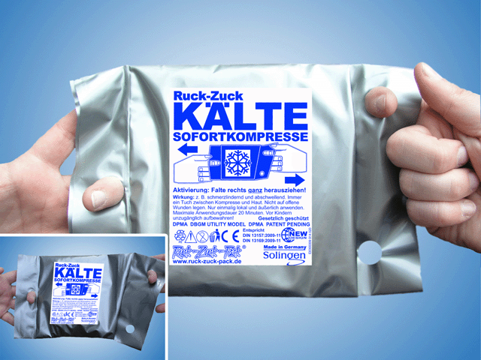
Brief: When injuries occur during exercise it is recommended by medical professionals that you cool down the injured area to reduce swelling and inflammation.

You are working for a company that is looking to create an ice pack to treat sports injuries. The company would like you to evaluate whether dissolving ammonium nitrate in water could be a suitable ‘reaction’ to use in their ice packs.

Your job is to evaluate the effectiveness of this ‘reaction’ and report back to the company with your recommendations that must be based on scientific evidence.

Apparatus list (read the method below and write an apparatus list)

Method

- Add 25 cm³ of water into a polystyrene cup placed inside a large glass beaker.
- Record in the table below the initial temperature of the water to the nearest 0.5 ºC using a thermometer.
- Add one spatula of ammonium nitrate, stir and record the highest/lowest temperature.
- Wash the mixture down the sink and repeat 3 times using the same polystyrene cup

Results

 | Repeat 1 | Repeat 2 | Repeat 3 | Average
Initial temperature of the water (ºC)
Final temperature of the mixture (ºC)
Temperature change (ºC)

Calculations

- Now, use your results to work out the average energy change for the reaction per mole of water.

Heat energy per mole of water = ……………………. kJ/mol

Evaluation

- Was the dissolving of ammonium nitrate endothermic or exothermic? How do you know?

- Why might the energy change calculated not be entirely accurate?

- Write a brief report to your company outlining whether you think dissolving ammonium nitrate in water would be suitable to use in an ice pack. Consider the temperature and energy change, the cost of chemicals, the equation on page 1, the hazard of the chemicals and any other factors that you think are important. What other experiments would you like to perform to help you come to a better judgement if you had more time?

Progress: further resources on enthalpy changes are available here: http://www.thescienceteacher.co.uk/enthalpy/

