Topic | Bonding | Level | GCSE/A Level
Outcomes | - To explain why different substances have different melting points by considering their bonding and structure

Understanding the world around us: why is water a liquid at room temperature and salt solid?

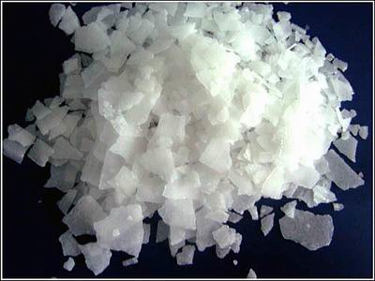
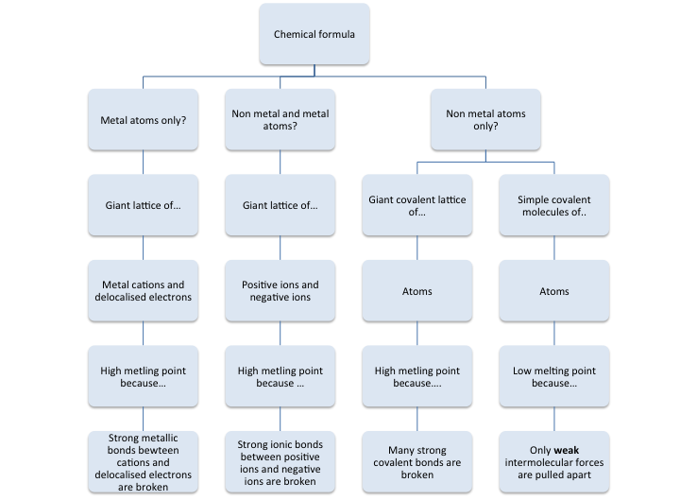

When a substance melts energy is required to break the forces of attraction between the particles. This is why a substance needs to be heated when it melts. Different substances have different bonds that need to be broken, some are strong and some are weak.

Exactly which bond is broken depends on the bonding in the substance and how the particles are held together. Use the flow chart above and your own knowledge to complete the table and questions below.

Name | Formula | Melting point  (ºC) | State at room temperature | Type of structure: ionic, simple covalent, giant covalent or metallic? | What is the force of attraction between the particles that must be overcome (broken) when the substance melts
Water | H₂0 | 0 | liquid | Simple covalent | Weak intermolecular forces
Diamond |  | 3550
Oxygen |  | -218.8
Sodium chloride |  | 801
Magnesium |  | 650
Magnesium oxide |  | 2852
Silicon dioxide (sand) |  | 1600
Carbon dioxide |  | -78
Graphite |  | 3652
Sodium |  | 97.72
Ammonia |  | -77.3

Look at your table and answer the following questions.

- What type of structure has the highest melting point; ionic, simple covalent, giant covalent or metallic?

- What type of structure has the lowest melting point; ionic, simple covalent, giant covalent or metallic?

- Annotate the diagram below to show which bonds are broken when the substance melts. Now draw a diagram to show what the structure would look like as a liquid.

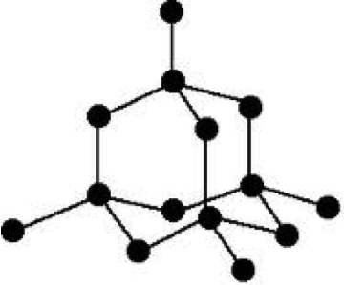
Solid Diamond
Heat
Liquid Diamond

- Using the table above and the flow chart to help you, explain the following:

  - Why does diamond have a high melting point?
  - Why does oxygen have a low melting point?
  - Why does MgS have a higher melting point than CO₂?

Progress: further resources on bonding are available here: http://www.thescienceteacher.co.uk/bonding/

