Revision questions – BIOLOGY
Section 1: The nature and variety of living organisms
- Characteristics of living organisms
- Explain what the acronym MRS GREN refers to and define each living process.
- Variety of living organisms
- Describe the common features shared by organisms within the following main groups:
Kingdom | Examples  (give two) | Uni-/multicellular? | Cells contain chloroplasts? | Can photosynthesise?
PLANTS
ANIMALS
FUNGI
BACTERIA
PROTOCTISTS
VIRUSES

Kingdom | Cell walls?  If Y, made of…? | Store carbohydrates as…? | Cells contain a nucleus? If N, then what?
PLANTS

ANIMALS

FUNGI

BACTERIA

PROTOCTISTS

VIRUSES

- Define the term ‘pathogen’.
- State the four kingdoms that include pathogens.
- Fungi feed by ‘saprophytic nutrition’. Explain what this means.
Section 2: Structures and functions in living organisms
- Levels of organisation
- Put the following in order from smallest to largest and define each term: organ, cell, organ system, organelle, tissue.

- Cell structure
1. Draw and label an animal cell and a plant cell.
2. Annotate your drawings above to describe the function of each cell structure.
3. Copy and complete the table to compare the structures of animal cells and plant cells:
Present in both animal and plant cells | Only present in plant cells

c) Biological Molecules
1. State the elements present in carbohydrates, proteins and lipids.
2. Copy and complete the table to describe the structure of these biological molecules:
Large molecule | Smaller basic unit
Carbohydrate
 | Amino acids
Lipids

3. Describe the test for glucose and for starch.
4. Enzymes are biological catalysts. Explain what this means.
5. Name the enzymes involved in breaking down large molecules into smaller basic units:
- Carbohydates are broken down into glucose by …
- Proteins are broken down into amino acids by …
- Lipids are broken down into fatty acids and glycerol by …
6. Describe and explain the effect of temperature on enzyme action:
- low temperatures (kinetic energy, collisions)
- optimum temperature
- high temperatures (denatured, active site)
7. Describe and explain the effect of pH on enzyme activity:
- optimim pH
- Lower than optimum pH i.e. more acidic (denatured, active site)
- Higher than optimum pH i.e. more alkaline (denatured, active site)
8. Describe an experiment to investigate the effect of pH on the breakdown of hydrogen peroxide by catalase (an enzyme present in potatoes) – use CORMS (Revision Guide p.6)
9. Describe an experiment to investigate the effect of temperature on the breakdown of starch by amylase (the ‘amylase clock experiment’) – use CORMS (Revision Guide p.6)
d) Movement of substances into and out of cells
1. Define diffusion
2. Define osmosis
3. Define active transport
4. Explain the importance of turgid plant cells as a means of support.
5. Describe and explain how the followings factors affect the rate of movement of substances into and out of cells:
- Temperature (as temperature increases, rate of movement … because …)
- Surface area to volume ratio (the higher the surface area to volume ratio, the … the rate of movement because)
- Concentration gradient (the higher the concentration gradient, the … the rate of movement because …)
6. Calculate the surface area to volume ratio of the following cubes:
- A – 4 x 4 x 4
- B – 6 x 6 x 6
7. Describe an experiment to demonstrate the effect of surface area to volume ration on diffusion in a non-living system (agar cubes made with sodium hydroxide and phenolphthalein indicator placed in hydrochloric acid) – use CORMS (Revision Guide p.9)
8. Describe an experiment to investigate osmosis in potato cells (Revision guide p. 9)
e) Nutrition
Flowering plants
- What is the word equation for photosynthesis?
- How does a plant obtain water?
- How does a plant obtain carbon dioxide and remove oxygen?
- What happens to the sugar made by photosynthesis? State 4 examples.
- Why is the leaf described as an organ?
- Why is photosynthesis described as an endothermic reaction?
- State the function of chlorophyll.
- Describe the structure of a leaf.
- Describe and explain how a leaf is adapted for photosynthesis.
- Describe how to test a leaf for starch.
- Describe an experiment that proves that light is needed for photosynthesis.
- Describe an experiment that proves that chlorophyll is needed for photosynthesis.
- Describe an experiment that proves that carbon dioxide is needed for photosynthesis.
- How do you de-starch a plant?
- Explain how the method of de-starching a plant removes its starch (hint: think about the processes of photosynthesis and respiration)
- Describe how to prove that oxygen is a product of photosynthesis (Hint: Canadian pondweed)
- What are the limiting factors for photosynthesis?
- Describe how you could investigate the effect of light intensity on the rate of photosynthesis (Hint: Canadian pondweed, a lamp and a 1m ruler).
- Sketch a graph to show the effect of light intensity on the rate of photosynthesis.
- Describe and explain the effect of light intensity on the rate of photosynthesis, using the term limiting factor.
- Describe and explain the effect of carbon dioxide on the rate of photosynthesis, using the term limiting factor (same as light intensity)
- Sketch a graph to show the effect of temperature on the rate of photosynthesis.
- Describe and explain the effect of temperature on the rate of photosynthesis (Hint: low – kinetic energy, enzymes, collisions; high – enzymes, denatured, active site)
Humans
- Define the term ‘balanced diet’.
- Copy and complete:
Food group | Sources rich in this food group | Function
Carbohyrdates
Protein
Lipid
Vitamin A
Vitamin C
Vitamin D
Calcium
Iron
Water
Fibre
- Describe and explain how energy requirements vary between the following:
A 27-year old woman and a 27-year old pregnant woman
A 16 year old boy and an 80 year old man
An office worker and a construction worker
- Describe the role of the mouth in the digestive process (salivary glands, amylase, teeth)
- Name and describe the process by which food is moved through the oesophagus (muscle, contract, push/squeeze)
- Describe the role of the stomach in digestion (muscular walls, churn, pepsin (a protease), hydrochloric acid
- Describe the role of the pancreas in digestion
- State what process happens in the small intestine.
- Describe the role of the large intestine in digestion.
- Describe the role of rectum in digestion.
- Describe the role of the anus in digestion.
- Define the following: ingestion, egestion, absorption, assimilation, egestion.
- Distinguish between egestion and excretion.
- Describe the structure of a villus and explain how this helps absorption of the products of digestion in the small intestine.
- Give two examples each of chemical and mechanical digestion.
- Bile: made in the …, stored in the …, released by the …?
- Describe the two functions of bile.
- Describe an experiment to investigate the energy content in a food sample – use CORMS (Revision guide p.14)
- Explain how the accuracy of this experiment can be improved.

f) Respiration
1. Write the word and balanced symbol equation for aerobic respiration.
2. Write the word equation for anaerobic respiration in muscle cells.
3. Write the word equation for anaerobic respiration in yeast.
4. Describe the differences between aerobic and anaerobic respiration.
5. Describe how the following experiment could be used to prove that maggots respire to produce carbon dioxide.
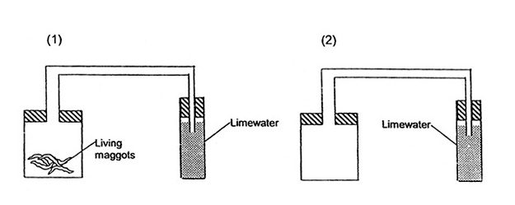

6. Explain the purpose of experiment (2) above.
7. Explain how the following experiment can be used to demonstrate that germinating seeds generate heat when they respire.
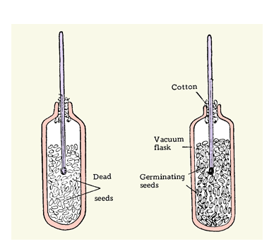
8. What is the purpose of the experiment done using dead seeds?
9. Explain why the seeds must be sterilised.
10. Why use cotton wool to seal the flask and not a rubber bung?

g) Gas exchange
- Describe the diffusion of the gases oxygen and carbon dioxide in the following examples:
- At the alveoli
- In animal cells
- In a leaf
Flowering plants
- Describe the net exchange of gases from a leaf during the day (high light intensity – more photosynthesis than respiration).
- Describe the net exchange of gases from a leaf at night (low light intensity – only respiration).
- Explain how the structure of a leaf is adapted for gas exchange:
Broad
Thin
Air spaces
Stomata
Guard cells
- Hydrogen carbonate indicator is orange. In high carbon dioxide levels it turns yellow. In low carbon dioxide levels it turns purple. State and explain the colour that you would expect the following solutions to turn after 24 hours.
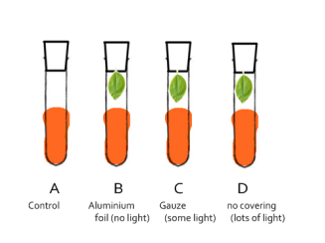
Humans
- Label diagram of the thorax and annotate with the function of each structure:
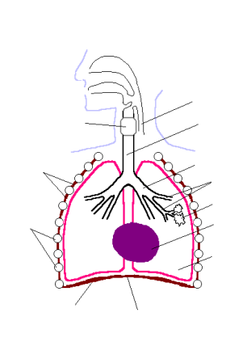
- Describe the role of the diaphragm and intercostal muscles in ventilation: (contract, down (diaphragm), up and out (muscles), volume, pressure)
- Explain how the alveoli are adapted for gas exchange by diffusion between air in the lungs and blood in the capillaries.
- Describe the biological consequences of smoking on the lungs and the circulatory system, including coronary heart disease.
- Describe an experiment you could carry out to investigate the effect of exercise on breathing rate – use CORMS.
- Describe and explain the effect of exercise on breathing rate.

h) Transport
1. Explain why an amoeba (unicellular organism) can rely on diffusion for movement of substances into and out of it, whereas humans need a heart and circulatory system.
Flowering plants
- State two things carried by the phloem and name this type of transport.
- Explain why plants need the minerals magnesium and nitrates.
- Describe how a plant obtains minerals (Hint: active transport)
- Name the two main transport systems in plants.
- State two things transported by xylem vessels.
- Describe how root hair cells take in water (Hint: osmosis)
- Explain how a root hair cell is adapted for absorbing water.
- State how water is lost from a plant.
- State the two processes that take place during transpiration.
- State the four factors that affect the rate of transpiration from a leaf (Hint: washing on a line!)
- Explain how these factors affect the rate of transpiration.
- State the apparatus used to measure the rate of transpiration.
- Describe how it is used to measure the rate of transpiration.
Humans
- State and describe the function of the four blood components.
- State four substances carried by the plasma.
- Describe and explain how a red blood cell is adapted for its function.
- Describe how the immune system responds to disease using white blood cells.
- State what is vaccination contains and explain how this gives a person immunity to a disease.
- Describe the blood clotting process, including the role of platelets.
- Label the diagram of the heart:
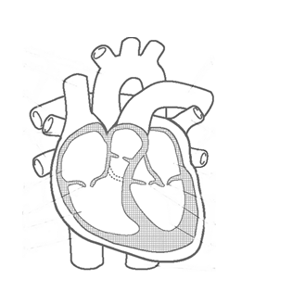
- Describe the structure of the heart.
- Describe and explain the effect of exercise on heart rate.
- Describe and explain the effect of adrenaline on heart rate.
- Draw a labelled diagram of an artery, a vein and a capillary.
- Compare the structure of an artery with a vein.
- State which organs these branches of the circulatory system are responsible for:
- renal
- coronary
- hepatic
- pulmonary

- Excretion
Flowering plants
- Carbon dioxide and oxygen are both excreted from leaves as waste products. Explain why.
Humans
- State the three organs of excretion.
- Label the parts of the urinary system and annotate your labels with a description of each structure:
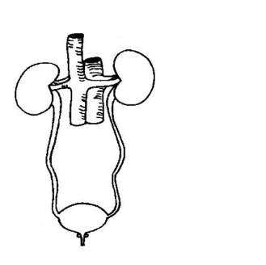
- Label the diagram of a nephron:
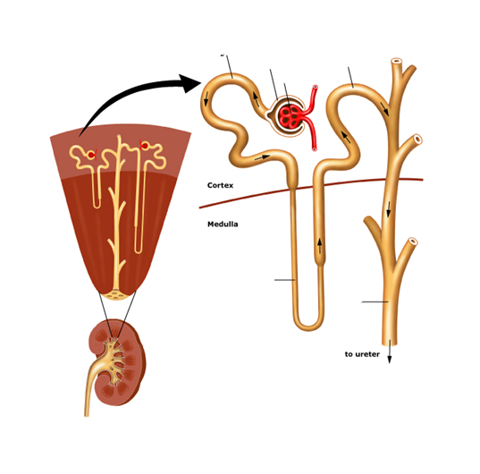
- Describe the process of ultrafiltration at the Bowman’s capsule.
- State the components of the glomerular filtrate.
- Describe the process of selective reabsorption.
- State where in the nephron water is reabsorbed.
- State where in the nephron glucose is reabsorbed.
- Describe the role of ADH in regulating water levels after a person has done some exercise on a hot day.
- State the components of urine.

j) Coordination and response
1. Define homeostasis and give two examples of homeostasis in the human body.
2. Define ‘stimulus’, ‘receptor’ and ‘effector’
3. State the name of the plant hormone that enables a plant to respond to stimuli.
4. Describe the positive phototropism of stems using the diagram below to help:
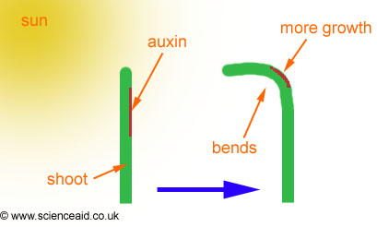
- Describe the geotropic response of roots and stems, using the diagram below to help:
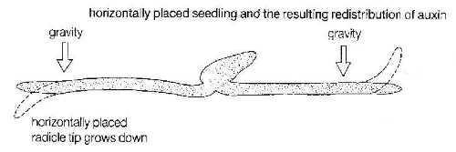
- Complete the table to compare nervous and hormonal control:
 | Nervous | Hormonal
Nature of communication

Message carried by …

Speed at which message is carried by
Duration of response

- What does the ‘CNS’ stand for and what is it made up of?
- Describe the stimulus-response pathway that enables you to catch a ball when you see it coming towards you.
- Describe the reflex arc that makes you withdraw your hand from a hot object.
- Label this diagram of the eye and annotate your labels to describe the function of each structure.
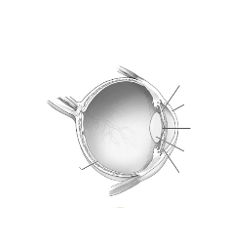
- Describe and explain the iris reflex
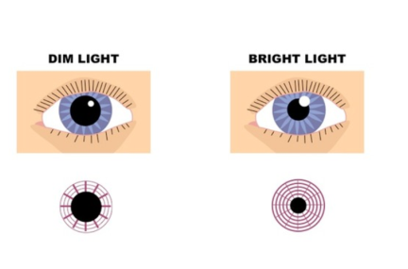
 | Dim light | Bright light
Radial muscles
Circular muscles
Size of pupil (constricted/dilated)
Importance of response

- Describe accommodation
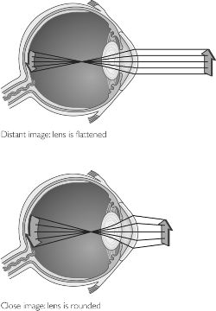
 | Near object | Far object
Ciliary muscle
Suspensory ligament (tight/slack)
Shape of lens

- Describe the role of the skin in cold and warm temperatures with reference to sweating, vasoconstriction and vasodilation.
- Complete the following table about hormones:
 | Source | Role | Effects
ADH
Adrenaline
Insulin
Testosterone
Progesterone
Oestrogen

Section 3: Reproduction and inheritance
- Reproduction
- Complete the table to compare asexual and sexual reproduction:
 | Asexual | Sexual
Number of parents?
Mitosis or meiosis?
Gametes involved?
Offspring genetically identical or different to parents?

- Describe the process of fertilisation using the terms male and female gamete, zygote, embryo, meiosis and mitosis.
Flowering plants
- Label the diagram of a flower:
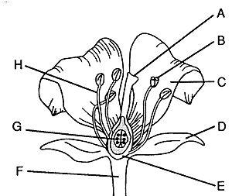
- Complete the table to describe adaptations for wind- and insect pollination:
 | Wind | Insect
Petals
Scent
Nectary
Filaments long/short?
Features of pollen grains
Position of stigma
Structure of stigma

- Describe the sequence of events in which the growth of a pollen tube (following pollination) leads to fertilisation and seed and fruit formation.
- State and explain the conditions needed for seed germination.
- Explain the changes in dry mass of the plant at points X and Y on the graph below (Describe how germinating seeds utilise food reserves until the seedling can carry out photosynthesis):
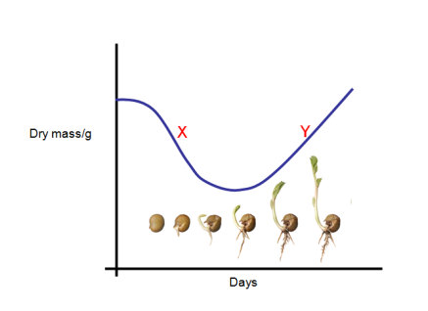
- Describe tow methods of asexual reproduction in plants: natural (strawberry plants producing runners) and artificial (taking cuttings)
Humans
- Label the diagrams of the male and female reproductive systems and annotate the diagrams with the function of each part:
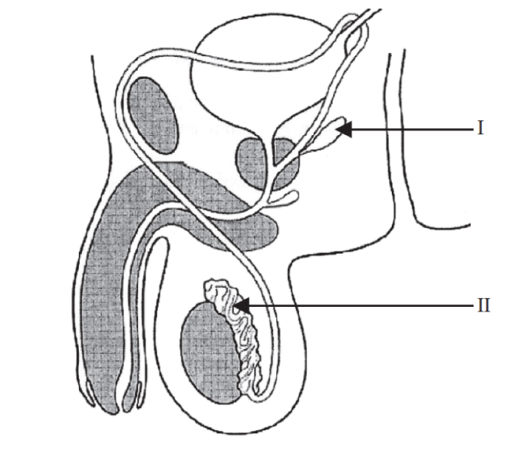
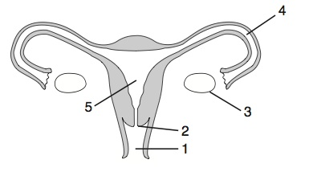
- Describe the role of oestrogen and progesterone in the menstrual cycle (effect on uterus lining).
- Describe the role of the placenta in the nutrition of the developing embryo.
- Describe the role of the placenta during the development of the embryo.
- List the secondary sexual characteristics that develop at puberty in males and females.

- Inheritance
- Describe the relationship between nucleus, chromosomes, genes and DNA
- Define the term ‘gene’.
- Describe the structure of a DNA molecule.
- Define the term ‘allele’.
- Define the following terms: dominant, recessive, homozygous, heterozygous, phenotype, genotype and codominance.
- Two parents are heterozygous for Cystic Fibrosis. Draw a genetic diagram to show the probability that they will have a child with the disease.
- Use the diagram below to answer the question about cystic fibrosis (a recessive condition):
- Explain how Frank inherited CF
- State Wilf’s genotype
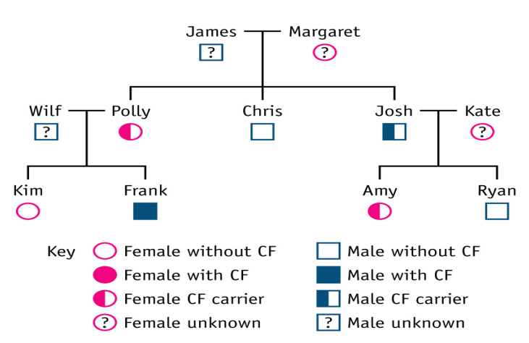
- Describe the determination of sex of offspring at fertilisation, using a genetic diagram.
- Draw a simple diagram to show the process of mitosis.
- Draw a simple diagram to show the process of meiosis.
- Why do you have a mixture of both your mother’s and your father’s characteristics? Why do you look similar to, but not identical to your brothers and/or sisters?
- What is the diploid number of a human cell? What is the haploid number of a human sperm/egg cell?
- Give examples of variation that is caused by genes only (e.g. blood type), environment (e.g. scar) only or both (e.g. weight).
- Define the term ‘mutation’. Some people say that all mutations are harmful – what do you think?
- Describe how giraffes evolved to have long necks, using Darwin’s theory of evolution by natural selection.
- Describe how the overuse of antibiotics is leading to the evolution of antibiotic-resistant strains of bacteria, which could lead to infections being difficult to treat.
- What environmental factors can cause mutations?
Section 4: Ecology and the environment
- The organism in the environment
- Define the terms population, habitat, community and ecosystem.
- Describe how you could estimate and compare the dandelion populations of Hackney Downs with Clissold Park.
- Mary wants to find out if the distribution of daisies changes as you go further away from the main road. How could she investigate this?

- Feeding relationships
- Draw food chain with the following organisms: aphid (greenfly), blackbird, leaves, cat and label the producer, primary consumer, secondary consumer, tertiary consumer.
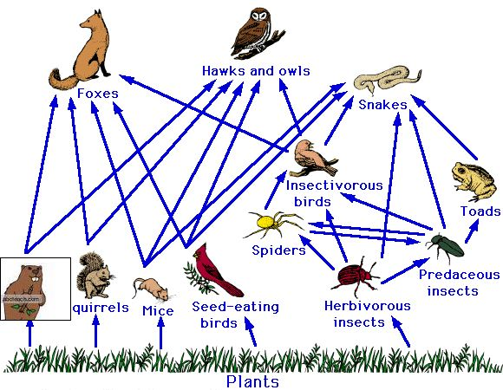
- Using the food web above: a) Draw a food chain that includes toads. b) Draw a food chain that is four organisms long. c) A disease wipes out all of the toads – explain the effect this would have on the other organisms in the food web.
- Explain the limitations of pyramids of number using the example below:
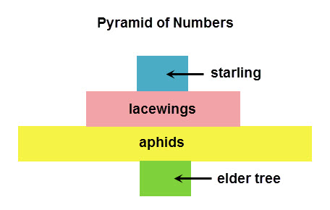
- What shape is a pyramid of biomass and pyramid of energy ALWAYS?
- Explain why only about 10% of energy is transferred from one trophic level to the next.

- Cycles within ecosystems
- Explain the following stages in the water cycle: evaporation, transpiration, condensation and precipitation.
- Explain the role of trees in the water cycle.
- Describe the stages in the carbon cycle, including respiration, photosynthesis, decomposition and combustion.
- Describe the stages in the nitrogen cycle, including the role of nitrogen fixing bacteria, decomposers, nitrifying bacteria and denitrifying bacteria.

- Human influences on the environment.
- Describe the consequences of air pollution by sulphur dioxide and by carbon monoxide.
- State the names of 5 greenhouse gases.
- Describe how human activities contribute to greenhouse gases.
- Explain the consequences of global warming.
- Describe the biological consequences of water pollution by sewage.
- Describe how the leaching of minerals from fertilisers can lead to eutrophication.
- Describe the effects of deforestation, including leaching, soil erosion, disturbance of the water cycle and the balance of atmospheric oxygen and carbon dioxide.
Section 5: Use of biological resources
- Food production
Crop plants
- Food production
- Describe how glasshouse and polythene tunnels can be used to increase the yield of certain crops.
- Explain the effect of increased carbon dioxide and increased temperature in glasshouses on yield of crops.
- Explain how fertilisers increase crop yield.
- Give an example of biological control.
- State three advantages of biological control over chemical pesticides.
Microorganisms
- Describe the stages in the production of beer
- Describe how you could carry out an investigation into the effect of temperature on the rate of carbon dioxide production by yeast.
- Describe the stages in the production of yoghurt and name the microorganism used.
- Explain the following features of a fermenter: the need for aseptic conditions, nutrients, optimum temperature and pH, oxygenation and agitation (stirring)
Fish farming
- Explain the following features of methods used in fish farms to produce large numbers of fish:
Feeding methods (what and how), maintenance of water quality, control of intraspecific and interspecific predation, control of disease, removal of waste and use of selective breeding.

- Selective breeding
- Describe how a plant grower could selectively breed his tomato plants to obtain large AND sweet tasting tomatoes.
- Describe how a farmer could selectively breed his cows to produce large quantities of sweet-tasting milk.

- Genetic modification (genetic engineering)
- Explain how genetic engineering can be used to produce a rabbit that glows in the dark (include the terms fluorescence gene, jelly fish, restriction enzyme, ligase, zygote, embryo, surrogate rabbit).
- State two examples of vectors that can be used in genetic engineering.
- Explain how a large amount of pure human insulin is made by genetically modified bacteria in a fermenter.
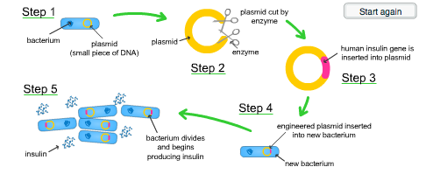
- State the advantages and disadvantages of using genetically modified plants to improve food production (increase yield), using pest-resistant plants as an example.
- Define the term ‘transgenic’

- Cloning
- Describe the process of micropropagation (tissue culture).
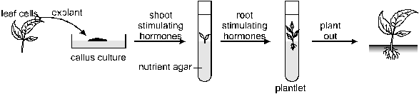
- State the advantages of micropropagation over traditional methods of growing plants.
- Explain how Dolly the sheep was made (cloning), using the terms diploid nucleus, body cell, enucleated egg cell, electric shock, embryo, surrogate sheep
