Topic | Dynamic equilibrium | Level | GCSE/A Level (or any other course for students aged 14-18)
Outcomes | - To understand what happens to the rates of the forward and reverse reactions and concentrations of reactants and products at dynamic equilibrium

Understanding Chemical Equilibria: a simple but powerful model

This simple model will help you to understand the key concepts involved in equilibira. We will be using a physical process to explain the key points first; once understood, these ideas can be applied to chemical equilibria.

The model: A small beaker of water is placed in a large upturned beaker. The edges of the large beaker are sealed with plasticine so that a closed system is made, where no water can escape or enter. After a period of time a state called dynamic equilibrium is reached.

Two changes are happening in this system:

Reaction 1: H₂O(l) H₂O(g)
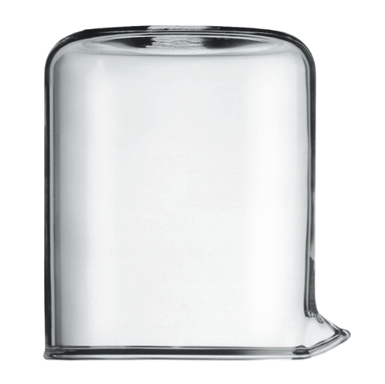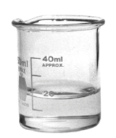
Reaction 2: H₂O(g) H₂O(l)

Questions about the model

- Using the equations above, describe what happens to the water particles when (i) the beaker is first placed inside the jar and (ii) what happens after a period of time. Annotate the diagram above to show what is happening.

- At dynamic equilibrium, the rate of reaction 1 and reaction 2 become equal. How would you know, from observing H₂O(l) in the beaker, when dynamic equibilirum has been reached?

- At dynamic equilibrium, what can you say about the amounts of H₂O(l) and H₂O(g) inside the system?

- For both reactions, state and explain whether they are exothermic or endothermic.

- Describe and explain the effect on the position of equilibrium of increasing the temperature. What would you observe?

- What is the relationship between the level of H₂O(l) in the small beaker and the position of equilibrium?

- Sketch a graph to show what happens to the rate of reaction 1 and reaction 2 overtime. Mark on this graph when you think dynamic equilibrium has been reached.

Progress: further resources on equilibria are available here: http://www.thescienceteacher.co.uk/equilibria/

