Topic | Evolution | Level | GCSE/A Level
Outcomes | - To think deeply about the concept of evolution by natural selection

So you think you understand evolution?

- Why have humans not evolved to breath underwater?

- Did humans evolve from chimpanzees? If so, then why are chimpanzees still here?

- Does natural selection differ from evolution or are they the same?

- Are humans still evolving despite the NHS?

- What evidence do we have that life evolved only once, and not many times independently?

- Look at the phylogenetic tree below and answer the following questions:

- Are mammals more closely related to Lizards or Frogs?
- Are Birds less evolved than Mammals?
- Are Alligators more closely related to Birds or Turtles, or are they equally related to both?
- What do you think the common ancestor of Birds and Alligators would have looked like? Can you draw your ‘hypothetical’ ancestor?

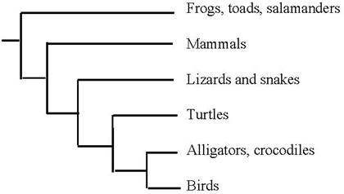

progress: further resources on evolution are available here: http://www.thescienceteacher.co.uk/evolution/

