Topic | Chromatography | Level | Key Stage 3 (or any other course for students aged 11-14)
Outcomes | - To interpret a chromatogram  - To use evidence from a chromatogram to support a claim

Applying knowledge: food colours and hyperactivity

Read the passage below about food colours and hyperactivity in children.
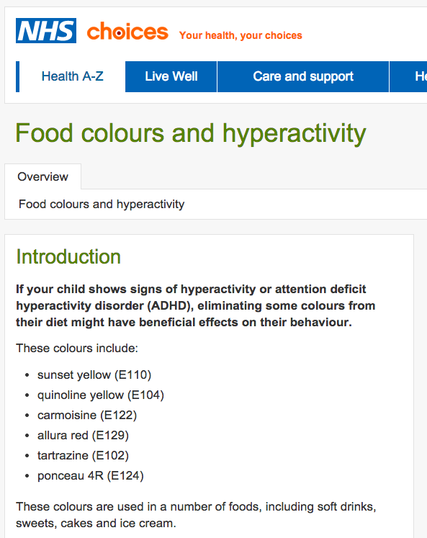
Taken from http://www.nhs.uk/conditions/food-additive-intolerance/Pages/Introduction.aspx
Mrs Gren wanted to find out if two drinks, drink X and drink Y, are suitable for her son to drink. They must not have any of the colourings that can cause hyperactivity.

She made a chromatogram using three colourings: E102 (tartrazine), E129 (allura red), E110 (sunset yellow) and with drinks X and Y.

The results are shown below.

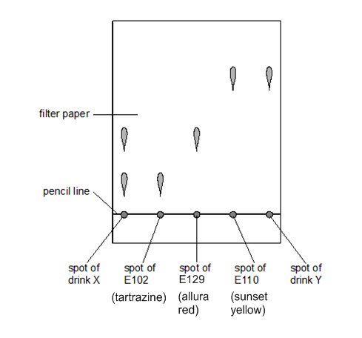
Questions

- What conclusions can you make about the suitability of drinks X and Y for Mrs Gren’s son? Explain you answer using information from the chromatogram.

- Mrs Gren suspects that drink X is worse for her son than drink Y. Does she have any evidence to support this claim?

- Mrs Gren suspects that E129 is actually a mixture of two food colours. What could she do next with the chromatogram to investigate this?

Progress: further resources on particles are available here: http://www.thescienceteacher.co.uk/particles

