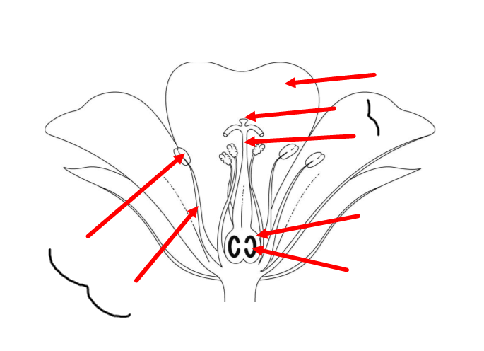
Male Parts of the Flower Insect Pollinated Flowers Female Part of the Flower
Stigma
If there are male and female parts to the plant, what kind of reproduction is it?

Where can the male sex cell be found?

Where can the can the female sex cells be found?

Why do you think that the male and female parts develop at different times?
Stamen
Anther
Carpel
Sample
Sepal
Sample
Filament

Style

Ovary

Petal

Not regarded as ‘male’ or ‘female’

