Topic | Valid methods | Level | GCSE
Outcomes | - To understand what a valid experiment is  - To use the terms independent variable, control variable and dependent variable correctly  - To plan a valid method to see who has the saltiest chips: McDonalds or Burger King

What does the word valid mean to you?

What does the word valid mean to you? We use the word in everyday conversations to mean something that is logical or reasonable. A valid argument is one that we often accept to be true. To a scientist it means something quite specific.

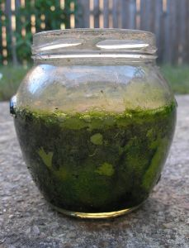
Imagine we want to investigate whether adding sugar increases the growth of algae. A sugar solution was added to a jam jar of algae each day and stirred. A similar jam jar was set up as a control, containing just the algae and water. A week later the algae from both jars was weighed. The algae grown in the sugar solution had the greatest mass. The scientist claimed that sugar increases the growth of the algae. Was she right? No, because this experiment was not valid. In fact it was the stirring of the solution that increased the growth of the algae and not the sugar itself.

An experiment is only valid if changes in the dependent variable are caused by changes in the independent variable. In the example above we were measuring changes in mass of the algae (the dependent variable), but this was being caused by changes in stirring and not the sugar (independent variable).

Questions:

- Why was this experiment not valid?
- How could the scientist make the experiment valid?
- What would be the control variables in this experiment?

Who has the saltiest chips: McDonald’s or Burger King?

You are now going to come up with your own valid method to find out who has the saltiest chips, McDonalds or Burger King? You will need to find out the total mass of NaCl present in an average box of large French fries from each restaurant.

You are going to be given 3 boxes of chips from each restaurant to test so that you can work out an average.

You are going to use the following fact to help you write your method:

NaCl is soluble in water whereas potato is not

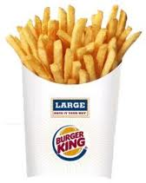

Instructions:

- What is your dependent variable?
- What is your independent variable?
- How are you going to extract and measure the mass of NaCl from the chips? Write a detailed method
- What are your control variables? How will you make sure that your results are valid?
- What are the limitations of your method?
- Can you be sure that you are measuring the mass of the NaCl only? Is it valid?

