Topic | What is science? | Level | GCSE
Outcomes | - To consider what science and the scientific method is

What is science? A simple demonstration

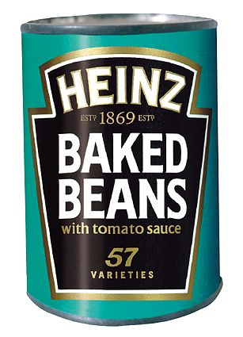
Aim:

The purpose of this simple demonstration is for students to begin to think about the questions – what is science and what do scientists do? Students are asked to make a prediction about what is inside a tin can and then test this prediction by ‘experimentation’.

Apparatus:

- Tin of beans and tin of peas with labels switched
- Beaker
- Tin opener

Method:

- Get the class to close their eyes
- Ask the students to think about the following questions:

  - What is Science?
  - What is it that Scientists do?
  - What is the point of studying Science at school?

- Get individual students to provide answers to these open questions. Put ideas on the board

- Take a tin of peas with a baked bean label on it.

- Ask students to predict what is inside the tin
  - How will they test this prediction?

- Open the tin and pour out the peas into a beaker.
  - Was the prediction correct?
  - Have we proved that there are no baked beans inside the tin?

Science is about making predictions using learned knowledge. In this example a prediction is made based on the labelling on the tin. These predictions are then tested by practical experimentation, in this example by opening the tin.

Science is a subject that involves making predictions (hypotheses) and then testing them. Science is about having good ideas that can be tested.

