Number of carbon atoms | Number of hydrogen atoms | Displayed formula e.g. 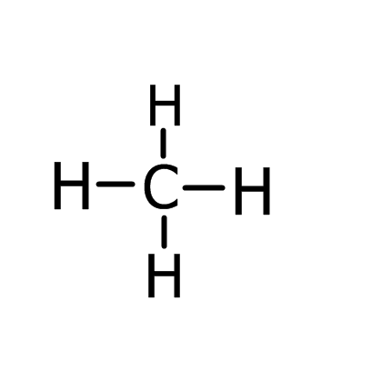 | Molecular formula e.g. CH₄ | Name of alkane
1
2
3
4
5
6
7
Questions
- Why is sugar not a hydrocarbon even through it contains hydrogen and carbon atoms?

- If a wet cloth is saturated what does that mean?

- Why do you think we say that alkanes are saturated?

- What is the relationship between the number of carbon atoms in an alkane and the number of hydrogen atoms?

- Can you create a mnemonic of to help you remember the names of the first five alkanes?

- An alkane has 107 carbon atoms. What is the molecular formula?

- Allkanes belong to the same homologous series, they have similar chemical properties and gradually changing physical properties. What physical properties do you expect to change as the length of the molecules increase?

