Topic | Simple Distillation | Level | Key Stage 3 (or any course for students aged 11-16)
Outcomes | - To describe and explain the changes that take place during distillation  - To label a distillation apparatus

Distillation: evaporation followed by condensation

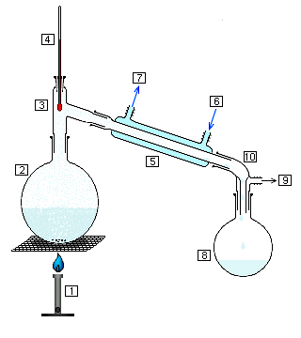

Label the diagram above

The life and times of a busy particle

Write a story about your time as a water particle that is in a mixture of ink particles with higher boiling points. Explain what happens to you as you pass through the apparatus above, from the minute heating begins until you have condensed back into a liquid and have been collected.

You should:

Write about any changes in state that happen during your journey.
Describe your motion and how this changes during your journey.
Describe your relationship with the other particles around you.
Describe what happens to you and your energy in the condenser.
Describe how you were able to escape the mixture but the ink particles couldn’t.

Oh dear….

A mixture of ink and water is being separated by distillation.

Oh, dear. Someone has set up the distillation apparatus incorrectly. In your groups decide what would happen if:

- They forgot to turn on the tap to the condenser

- They heated the mixture so that everything boiled

- The condenser was connected to the hot water tap

- They tried to separate a mixture where the components had the same boiling point

Progress: further resources on separating techniques are available here: http://www.thescienceteacher.co.uk/separating-techniques/

