Topic | Elements and compounds | Level | Key Stage 3 (or any course for students aged 11-14)
Outcomes | - To use chemical symbols for elements  - To identify elements using the periodic table  - To identify compounds

The Chemist’s Castle

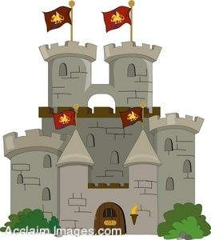

Once upon a time in a land far far away there lived a famous scientist called Mendeleev. He lived in a huge castle that had walls made of gold. Mendeleev loved to have parties where he could invite all his friends to tea that he made in his giant copper teapot. He would blow up balloons with helium gas and hang them from the castle walls. He would give his guests beautiful cups and plates made from silver and they would eat fish finger sandwiches with lots of salt and vinegar. The guests loved Mendeleev’s parties because they always finished with fireworks, made from iron and magnesium, which filled the sky with beautiful colours.

One day Mendeleev made a mistake. When he was filling his party balloons he used hydrogen instead of helium gas. At the end of the party when the fireworks went off, the balloons caught fire with a “BANG” and everyone was very scared. Luckily, the castle had carbon dioxide fire extinguishers to put the fire out. From this day forward Mendeleev always labels his gas jars carefully, using the name and symbol for the gas.

Questions:

- Underline all the different elements in this story.
- Find the symbols for these elements in your periodic table and write them into your book? What group and period is each element in?
- Find two compounds in this story. Write their names and chemical formulas into your book.
- Make up your own story using as many elements as you can. Rather than writing the name of the element in your story, use its chemical symbol.
- Why is it wrong to say that carbon dioxide is an element? Explain your answer.
- Why is it wrong to say that bread is a compound? Explain your answer.

Progress: further resources on elements and compounds are available here http://thescienceteacher.co.uk/elements-and-compounds/

