Topic | HIV/AIDS | Level | GCSE (or any other course for students aged 11-16)
Outcomes | To understand the difference between HIV and AIDS  To consider why it is important for people to know about infectious diseases  To suggest why viral diseases are harder to cure than bacterial diseases

HIV and AIDS

There is no cure for HIV/AIDS and there is no vaccine. Today the use of antiretroviral drugs can prevent the development of AIDS so HIV positive people can have an almost normal life expectancy.

Look at the graph below. This patient did not receive any treatment for their disease.
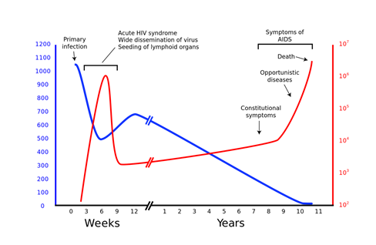
HIV particles per ml of plasma in blood
Number of white blood cells (cells/mm³)
Use the graph (source) and your own knowledge to answer the questions below.

- Is HIV a bacterium, virus, protist or fungus?
- Approximately how many years after infection do symptoms of AIDS start to show?
- Why do you think that many people who are infected with HIV do not realise they are infected?
- Why do patients infected with HIV die of other infections and cancers?
- What is the difference between HIV and AIDS?
- Suggest why more people die from AIDS in areas such as sub-Saharan Africa than the UK?
- Suggest why viral diseases are often harder to cure than bacterial diseases.
- Watch this video and suggest why it is important that people learn about HIV/AIDS at school.

