Topic | Pollination in plants | Level | GCSE (or any course for students aged 14-16)
Outcomes | - To describe and explain adaptations of wind, insect and mammal pollinated plants
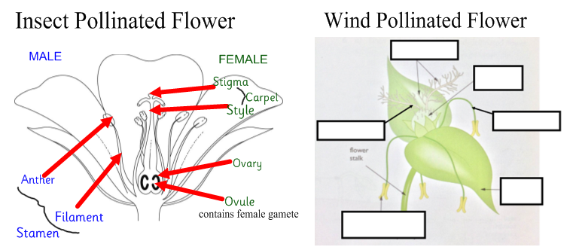

- Label the wind pollinated flower above.

2. Compare the structures of insect and wind pollinated flowers.
(Use correct comparative language. See box below for support)

3. Explain the significance of two of these adaptations to the plant for pollination.

Literacy support – comparative language
When comparing structures ensure they are referring to the same point (the colour of the petal, for example)
Whereas is a good connective to use.
…………………………………………………. whereas ………………………………………………
e.g. The insect pollinated flower has large, brightly coloured petals whereas the wind pollinated flower has smaller, duller coloured flowers.

You have looked at the adaptations for the insect and wind pollinated flowers.
Designing a mouse pollinated flower
So far we have looked at the adaptations for insect and wind pollinated flowers. You are now going to design your own flower that is pollinated by a mouse.
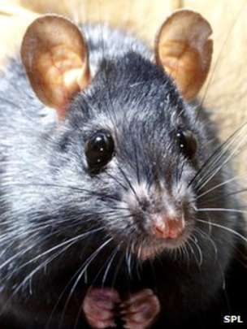
Designing a mouse pollinated flower

You design must include:
- A diagram of the flower
- All parts labelled
- An explanation of each adaptation

It does actually exist!! https://www.youtube.com/watch?v=Pwp5VRV4ZxY

Progress: further resources on plants are available here:
http://thescienceteacher.co.uk/plants/

