Topic | Adaptation | Level | GCSE (or any other course for students aged 11-16)
Outcomes | - To understand the term adaptation  - To generate and test a hypothesis about whether a feature of a plant is an adaptation

Adaptations of Mimosa pudica: testing your hypothesis

Mimosa pudica is a plant native to South America and Central America. It has been introduced to many other regions and is regarded as an invasive species in Tanzania, South Asia and South East Asia and many Pacific Islands.

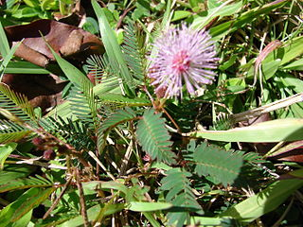

The plant has a very spectacular adaption: https://www.youtube.com/watch?v=g0LFBM3hOLs

Now, as you know, for a feature of an organism to be called an adaptation it has to actually help the organism survive in its habitat. In your pairs come up with as many hypotheses as you can as to why leaf folding could be an advantage to the plant.

Generate your hypotheses: The folding of the leaves helps the plant because….

Help: https://www.youtube.com/watch?v=rHxzDo5kJe8

Testing one hypothesis:
Now, chose one hypothesis from your list that you think is most likely to be true. In your groups come up with an experiment or experiments that you could do to test your hypothesis. You will need to include:

- How many plants you will use in your study
- What environmental condition will you change and how will you do this?
- What will be your evidence that the adaptation helps the plant?
- What will be your control?

Progress: further resources on evolution are available here: http://www.thescienceteacher.co.uk/evolution

