Topic | Enzymes | Level | GCSE (or any other course for students aged 11-16)
Outcomes | - To be able apply your knowledge of enzymes to explain new observations

Progress: further resources on biochemistry are available here: http://www.thescienceteacher.co.uk/biochemistry

 | Observation | Explanation of observation using your knowledge of enzymes
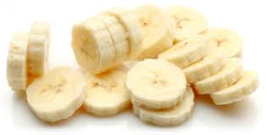 | Banana pieces go brown when they are exposed to air. This browning is stopped if you add lemon juice to the banana pieces.
 | Humans cannot survive on a diet of grass but cows can.
 | Humans die of hyperthermia when their body temperature remains above 40 °C for a period of time.
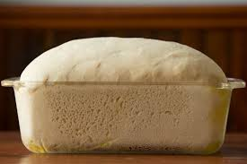 | When bakers make bread the dough is put in a warm place to rise.
 | Observation | Explanation of observation using your knowledge of enzymes
 | Banana pieces go brown when they are exposed to air. This browning is stopped if you add lemon juice to the banana pieces. | An enzyme in the banana called polyphenol oxidase (PPO, phenolase) in the presence of oxygen produces brown pigments known as melanins. If lemon juice is added this denatures the enzymes and so browning does not occur.
 | Humans cannot survive on a diet of grass but cows can. | Cows have many bacteria in their digestive system that produce cellulases. These enzymes break down the cellulose in the grass cell walls. Humans do not produce this enzyme and lack the specific bacteria to produce it. As enzymes are specific, if celluase is not produced then cellulose (the main component of grass) cannot be broken down.
 | Humans die of hyperthermia when their body temperature remains above 40 °C for a period of time. | At temperatures above 40 °C enzymes involved in metabolic pathways within the body such as cellular respiration become denatured and fail to work effectively.
 | When bakers make bread the dough is put in a warm place to rise. | Yeast are microorganisms that use the glucose in the bread to release energy and produce carbon dioxide as a waste product which causes the bread to rise. The yeast cells contain many enzymes which catalyse this reaction, these enzymes have an optimum temperature of 30 °C and so work at their fastest rate at this temperature.

