iGCSE Physics Specification Questions
Forces and Motion
- What does the gradient of a distance-time graph represent?
- State the equation linking average speed, distance moved and time.
- State the equation linking acceleration, change in velocity and time.
- What does the gradient of a velocity-time graph represent?
- What does the area under the line of a velocity-time graph represent?
- What three effects can a force have on an object?
- What is the difference between a vector and a scalar quantity?
- If a car engine gives 300 N of thrust forwards and there is 100 N of drag, what will be the resultant force? What will happen?
- What is friction?
- What is the equation that relates resultant force, mass and acceleration?
- What is the equation that relates weight, mass and acceleration due to gravity?
- Describe what happens to an object as it falls in terms of the forces acting on it and its motion.
- What equation relates stopping distance, thinking distance and braking distance?
- What factors affect thinking distance?
- What factors affect braking distance?
- What is the relationship between momentum, mass and velocity?
- How does a car safety belt reduce injuries?
- What is the law for conservation of momentum? Describe an example where it can be used to calculate the motion of objects after a collision or explosion.
- What is the equation linking force, change in momentum and time taken?
- What is Newton’s third law?
- What is the relationship between the moment of a force and its distance from the pivot?
- What is the centre of gravity of an object?
- What is the principle of moments? How can it be used to determine the effect of parallel forces acting in one plane?
- What happens if you apply a range of forces to an object such as a spring, a metal wire or an elastic band?
- What is Hooke’s Law? How can it be demonstrated graphically?
- What is elastic behaviour?
- Why does an Astronaut weigh less on the Moon than on Earth but more if they were on the Surface of Jupiter?
- What causes planets to orbit the Sun?
- What is the difference between the orbit of a planet or a moon and the orbit of a comet?
- What is the equation that links orbital speed, orbital radius and time period?
- Put these in order of size from smallest to largest: Milky Way galaxy, Earth, Hackney, Mossbourne and the Universe.

Electricity
- How many electrical hazards can you spot?
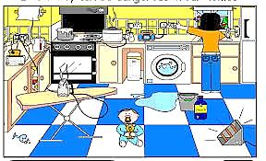
- How can insulation, earthing, fuses and circuit breakers be used to reduce electrical hazards?
- How can a resistor be used as a heater?
- State the equation that relates power, current and voltage.
- What is the equation that links energy transferred, current, voltage and time?
- What is the difference between alternating current and direct current?
- Which is more appropriate for a domestic lighting circuit, series or parallel?
- What happens to the current running through a series circuit if more voltage is applied?
- What happens to the current running through a series circuit if more components are added?
- Draw graphs to show how current varies with voltage in wires, resistors, filament lamps and diodes. How would you investigate these graphs experimentally?
- What happens to the resistance of an LDR if the light level drops?
- What happens to the resistance of a thermistor if the temperature drops?
- How could you use a diode to show which direction current is flowing around a circuit?
- What is the equation that relates voltage, current and resistance?
- What is current?
- What is the relationship between charge, current and time?
- What is voltage?
- What is a conductor? What is an insulator? Give three examples of each.
- Describe an experiment where an insulating material can be charged by friction.
- If a material has become positively charged, what has happened?
- What happens when like charges are placed close to one another? What happens when unlike charges are places close to one another?
- What are the risks of fuelling aircraft and other large vehicles and how can they be minimised?
- How does a photocopier work?

Waves
- What is the difference between a longitudinal and a transverse wave?
- Define amplitude, frequency, wavelength and the period of a wave?
- Do waves transfer energy and matter?
- What is the equation that relates wave speed, wave length and frequency?
- What is the relationship between time period and frequency?
- What is diffraction?
- Draw a diagram of diffraction comparing bass with treble. Label the wavelength.
- Draw a diagram of diffraction comparing red light with blue light. Label the wavelength.
- What are the parts of the electromagnetic spectrum from longest wavelength to shortest wavelength?
- What properties do all parts of the electromagnetic spectrum have in common?
- What are the uses of electromagnetic radiation?
- What are the risks of electromagnetic radiation and how can they be avoided?
- What is the law of reflection?
- What is a virtual image?
- Draw a diagram of an object and a virtual image using four lines and a reflective surface.
- What is the equation relating refractive index, angle of incidence and angle of reflection?
- How would you find the refractive index of a glass block?
- Why are optical fibres better than copper wire for transmitting information?
- Draw a diagram of total internal reflection down an optical fibre.
- What is the critical angle c?
- What is the relationship between the critical angle and the refractive index?
- What type of a wave is sound?
- What is the frequency range of human hearing?
- How could you measure the speed of sound in air?
- Draw a diagram comparing a loud, high frequency sound to a quiet, low frequency sound.

Energy resources and energy transfer
- What are the 9 forms of energy? Put them in a table with two headings: kinetic and potential.
- What is the law of conservation of energy?
- What is the equation for efficiency?
- Sketch a Sankey Diagram of a light bulb that is 30% efficient.
- What is conduction?
- What is convection?
- What is radiation?
- How can insulation be used to reduce energy transfer by conduction, convection and radiation?
- What is the relationship between work, force and distance moved in the direction of the force?
- What is work done?
- What is the equation relating gravitational potential energy to mass, the acceleration due to gravity and height?
- What is the equation relating kinetic energy to mass and velocity?
- Describe the energy transfers of a falling object considering the law of conservation of energy.
- What is power?
- What is the equation relating power, work done and time?
- Draw up a table of advantages and disadvantages including each of these energy resources: wind, water, geothermal, solar heating systems, solar cells, coal, oil, gas and nuclear power.

Solids, Liquids and Gases
- What is the equation that links density, mass and volume?
- How would you measure the density of tap water?
- What is the equation that links pressure, force and area?
- What is the equation that relates pressure difference, height, density and gravitational field strength?
- What is Brownian motion?
- How do gas molecules exert a pressure on the walls of a container?
- What temperature in ᵒC is absolute zero?
- Why can’t you get below absolute zero?
- How do you convert from ᵒC to K and from K to ᵒC?
- What happens to the average speed of gas molecules if you increase the temperature?
- What is the equation that relates pressure and Kelvin temperature?
- What is the equation that relates pressure and volume for a fixed mass of gas at constant temperature?

Magnetism and electromagnetism
- Draw a magnetic field pattern for a permanent bar magnet and between two bar magnets in both like and unlike pole arrangements.
- What two experiments could be used to find the magnetic field pattern of a magnet?
- How can you produce a uniform magnetic field?
- What is produced when a wire carries an electric current?
- What can you use to work out the direction of a field around a current carrying wire?
- What law governs the direction of a force exerted on a current carrying wire in a magnetic field?
- How can you increase the strength of a force on a current carrying wire in a magnetic field?
- Describe how a D.C. motor works.
- Describe how a loudspeaker or a microphone works.
- What happens when a conductor or coil is moved through a magnetic field or when a magnetic field moves through a conductor or coil?
- What factors affect the size of a voltage induced in a coil?
- Draw a labelled diagram of a transformer.
- Explain the difference between a step-up and step-down transformer.
- What is the equation that relates input (primary) and output (secondary) voltages to the turns ratio of a transformer.
- What is the equation that relates input power to output power for a 100% efficient transformer?

Radioactivity and particles
- Draw a labelled diagram of an atom.
- What does this mean?
- What do the terms atomic number, mass number and isotope mean?
- Draw a table comparing the following properties of alpha, beta and gamma radiation: form, source, charge, mass, speed, ionising power and penetration.
- Write out an example of a decay equation for each of the three main types of radiation.
- How does a Geiger-Muller detector work?
- Where does background radiation come from?
- What is activity and what is it measure in?
- How does the activity of a radioactive source reduce over time?
- What is meant by the term half-life?
- If it takes 120 years for the activity of a radioactive source to reduce by 50%, what is the half-life of the source?
- Describe two uses of radioactivity.
- Describe the dangers of radiation and how these risks can be reduced.
- Describe Geiger and Marsden’s gold foil alpha particle experiment.
- How did Geiger and Marsden’s findings over the deflection of alpha particles lead to Rutherford’s nuclear model of the atom?
- Describe the process of nuclear fission with a series of labelled diagrams.
- What is a chain reaction?
- Draw a labelled diagram of a nuclear fission reactor and explain the role played by the control rods and moderator.

Describing Experiments
- How can you check if results are reliable?
- What makes results valid?
- How can you improve validity?
- What is an independent variable?
- What is a dependent variable?
- What is a control variable?
- How can you improve reliability?

- Complete the table of examples of potential hazards and how the risks could be reduced.
Experiment | Hazard | Risk reduction
Radioactivity | Exposure can damage cells | Limit exposure time  Increase separation from sources  Use protective screens to absorb radiation
Spring extension
Electricity

- What does it mean if results are accurate?
- What is uncertainty?
- What might you do to improve the accuracy of an experiment? Give 4 examples.
- What is precision?
- What is the precision of this piece of data? (13.06)
- What is an anomalous result?
- What can cause an anomaly?
- How would you identify an anomaly in a set of data?
- Should you include anomalies when calculating averages?
- What is the difference between categoric and continuous data?
- For what type of data should you draw a bar graph?
- For what type of data should you draw a line graph?
- When drawing a graph what 6 things do you need to remember?

Use this graph for the following two questions
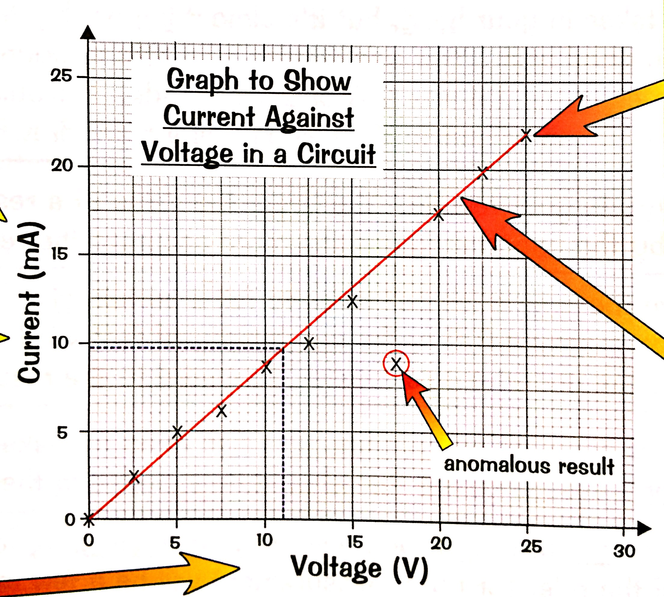

- Describe the relationship between the voltage and the current?
- What is the current when the voltage is 22.5 V?

- Justify why this answer is worth 6 marks by highlighting and annotating the answer to the following question:
