Topic | Dot and cross diagrams for ionic bonding | Level | GCSE (or any course for students aged 14-16)
Outcomes | - To draw dot and cross diagrams for ionic compounds

Winners and Losers: Ionic Bonding

When metals and non-metals react electrons are transferred from the metal to the non-metal to from ions. The ions formed have full outer shells.

Draw dot and cross diagrams to show how electrons are transferred when the following atoms react:
1 atom of sodium with 1 atom of chlorine:

WORKED EXAMPLE
Step 1 Draw the electronic arrangement of both atoms (use dots for one atom and crosses for the other)
Step 2 Now draw an arrow on your diagram to show the direction of the transfer of the electron(s)
Step 3 Now draw the ions formed after the electrons have moved: show the charge on the ions formed at the top right.

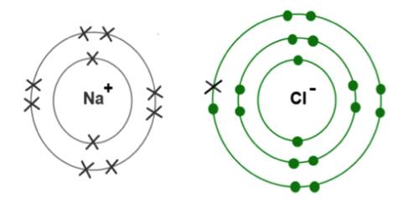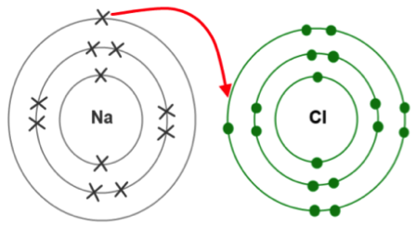
Ions that are formed
Atoms before they react

-
+

Repeat steps 1-3 for the following atoms in your book. Show only the outer electrons.

- 1 atom of lithium and 1 atom of chlorine
- 1 atom of sodium and 1 atom of fluorine
- 1 atom of magnesium and 1 atom of oxygen
- 1 atom of potassium and 1 atom of fluorine
- 1 atom of beryllium and 1 atom of sulphur
- 1 atom of magnesium and two atoms of fluorine
- 1 atom of calcium and two atoms of fluorine
- 2 atoms of sodium and one of oxygen
- 2 atoms of aluminium and 3 atoms of oxygen

Questions (please write out the question):

- What is the difference between a sodium atom and a sodium ion?
- Do metal atoms lose or gain electrons?
- How many valence electrons does an atom of chlorine have?
- What charge ions will atoms in group 7 of the Periodic table form?
- For metals, what is the relationship between the group number and the charge on the ion?
- For non-metals, what is the relationship between the group number and the charge on the ion?
- How many atoms of sodium would react with an atom of fluorine, explain your answer.
- How many atoms of sodium would react with an atom of oxygen, explain your answer.
- Why are electrons drawn with different symbols for each atom?

Progress: further resources on bonding are available here: http://www.thescienceteacher.co.uk/bonding/

