Topic | Planets, years and orbits | Level | Key Stage 3
Outcomes | - To understand what a year is?  - To state the order in which planets are located from the Sun

How old would you be if you lived on Mars?

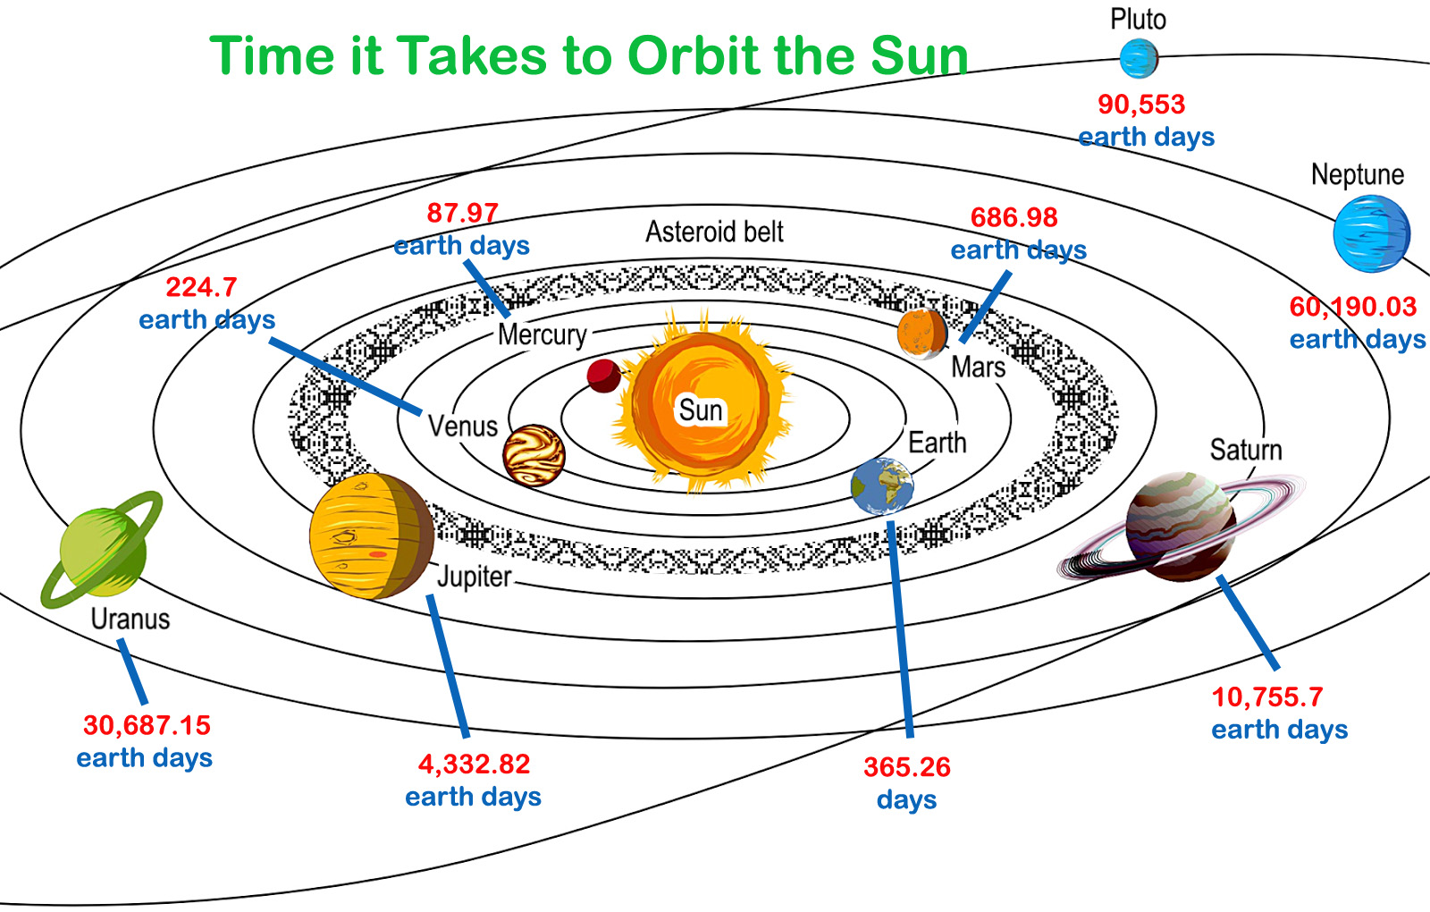
Figure 1 Image taken from http://planetfacts.org/wp-content/uploads/2013/05/Planet-Orbits.jpg
- What planet would you be living on if your birthday was every 88 years?

- How many candles would be on your next birthday cake if you lived on Mars?

- Can you work out your age if you lived on:
  - Mercury
  - Venus
  - Earth
  - Mars
  - Jupiter

- Write your own pneumonic to help you remember the order in which planets are located from the Sun

Progress: further resources on Earth and space are available here: http://www.thescienceteacher.co.uk/earth-and-space/

