Revising in Science

Revision needs to be an active process and cannot just be copying words from one page to another. This booklet will show you how to revise effectively:
- Summarise key points
- Make a useful revision card
- Turn information into pictures and diagrams
- Make a concept map

Summarising key points
Before you do this you should have:
- Read through the section from the revision guide
- Written a list of the key words from the section and defined each one.

A good summary should include:
- What, when, where, how, why?
- Pictures or diagrams where appropriate
- Link together key points as short sentences
- Use headings and subheadings
- UIs of colours to highlight information
For example:
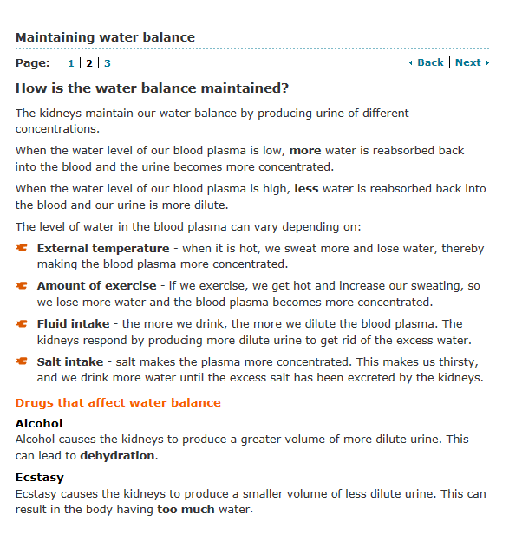

Becomes:
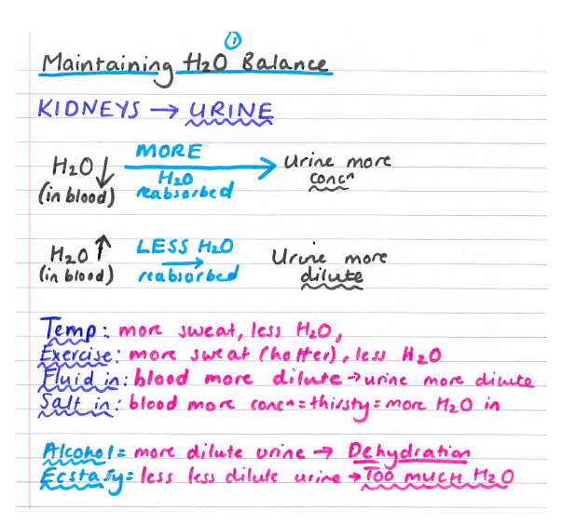

Making a revision card
A good revision card should:
- Have even less on it than the summary page! Keep the information short and precise.
- Use pictures and diagrams where appropriate.
- Be used as a two-sided document e.g. why not have questions on one side and answers on the other so you can use it to test yourself!?
- Use colours, highlighters, capital letters etc to show important information

For example:
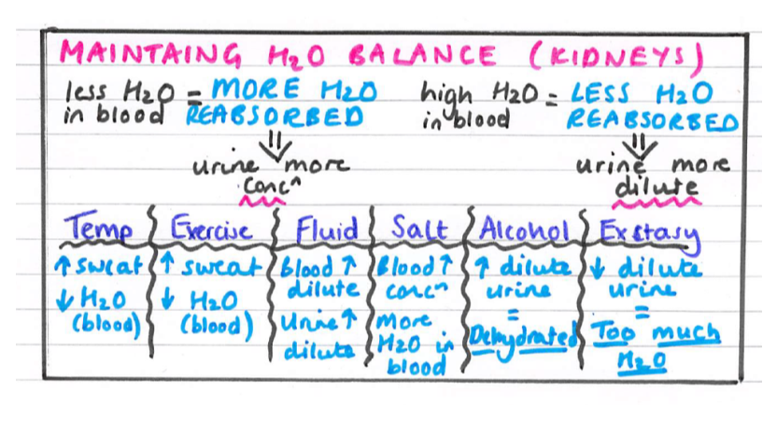

Turning information into pictures:
This is quite a simple one! But can be really helpful if you are a visual learner. The rules are: Only use FIVE WORDS MAXIMUM per page. For example:
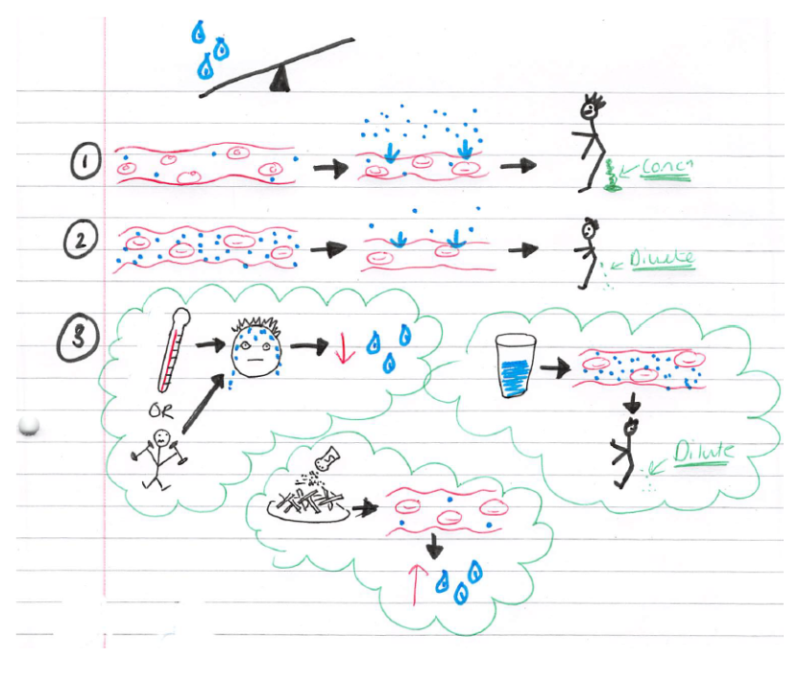

Concept maps
A good concept map should:
- Have lots of key words throughout (remember to use the list made at the start!)
- Link ideas together clearly using lines and arrows.
- Be simple. No long explanations are needed – try to limit each point to three words.
- Arrange the concepts in order of importance. Write the main concept at the top of a separate sheet of paper. Write the main points throughout the middle of the paper.
- Highlight important points in boxes and colours
For example:
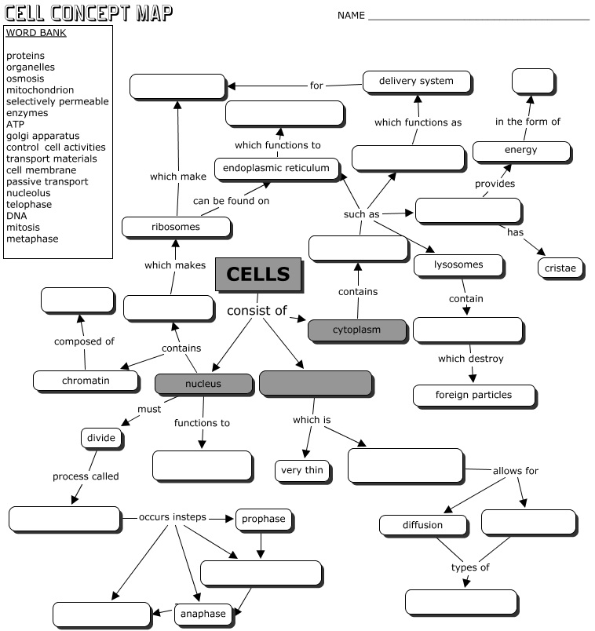
(You can complete this one as practice!)

