|  |  |  |  |
| --- | --- | --- | --- |
| **Topic** | Covalent bonding and dot and cross diagrams | **Level** | GCSE (or any other course for students aged 11-16) |
| **Outcomes** | 1. To understand how a covalent bond is formed 2. To be able to use molecular and displayed formula 3. To draw dot and cross diagrams for simple covalent molecules involving single, double and triple bonds | | |

This diagram shows two hydrogen atoms. Annotate the diagram to show all the attractive and repulsive forces that would exist.

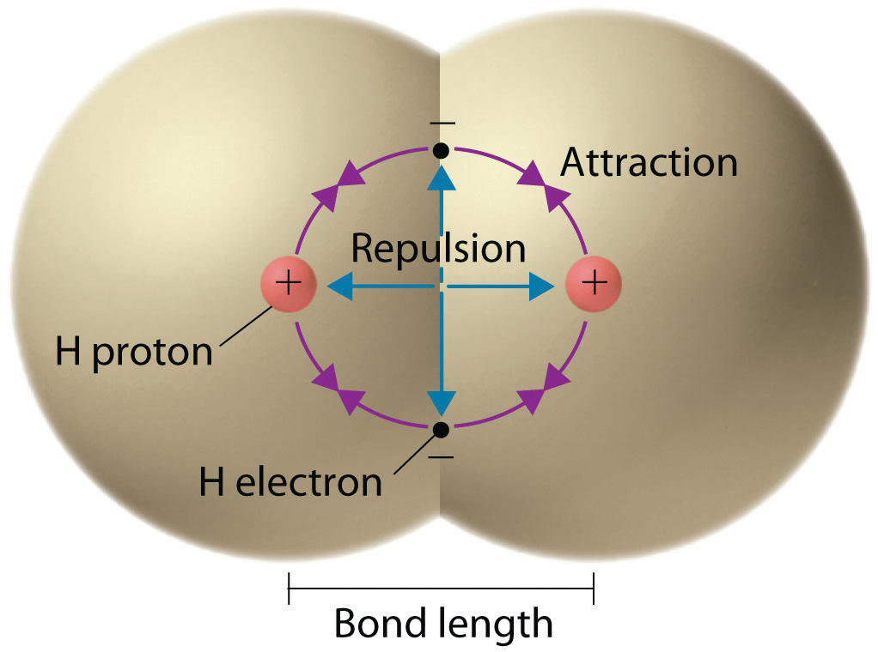

Figure 1 http://2012books.lardbucket.org/books/principles-of-general-chemistry-v1.0/s12-05-lewis-structures-and-covalent-.html

|  |  |  |
| --- | --- | --- |
| Molecular formula | Displayed formula | Dot and cross diagram |
| H2 | H-H |  |
| HCl | H-Cl |  |
|  |  | [http://www.bbc.co.uk/staticarchive/758431753b7324e5e0d633830acf71db965358d0.gif](https://www.google.com.co/url?sa=i&rct=j&q=&esrc=s&source=images&cd=&cad=rja&uact=8&ved=0ahUKEwiF4auryPPLAhUEmx4KHWGWBSUQjRwIBw&url=http%3A%2F%2Fwww.bbc.co.uk%2Fschools%2Fgcsebitesize%2Fscience%2Fadd_aqa_pre_2011%2Fatomic%2Fcovalentrev4.shtml&bvm=bv.118443451,d.dmo&psig=AFQjCNEI7taBvCMIS07nLg3NCGCRUltJvg&ust=1459810580779738) |
|  | [https://classconnection.s3.amazonaws.com/582/flashcards/1565582/jpg/water_displayed_formula-143AB3D4E721B38B499.jpg](https://www.google.com.co/url?sa=i&rct=j&q=&esrc=s&source=images&cd=&cad=rja&uact=8&ved=0ahUKEwiP29WVyPPLAhVGHR4KHccgACQQjRwIBw&url=https%3A%2F%2Fwww.studyblue.com%2Fnotes%2Fnote%2Fn%2Fcgp-c1-carbon-chemistry%2Fdeck%2F9423261&psig=AFQjCNEmJYEaYyqxmO_fmkh5TE2vkReMIQ&ust=1459810531736285) |  |
| NH3 |  |  |
|  | [http://www.bbc.co.uk/staticarchive/8188e0f152f521c07dd4e9baf299b92e92efc34b.gif](https://www.google.com.co/url?sa=i&rct=j&q=&esrc=s&source=images&cd=&cad=rja&uact=8&ved=0ahUKEwiI057MyPPLAhVIbB4KHTROByQQjRwIBw&url=http%3A%2F%2Fwww.bbc.co.uk%2Fschools%2Fgcsebitesize%2Fscience%2Fadd_ocr_gateway%2Fperiodic_table%2Fcovalentbondingrev1.shtml&bvm=bv.118443451,d.dmo&psig=AFQjCNE1GMi6ekymjqJmp9UG5pXcnFT7FA&ust=1459810650513737) |  |
|  |  | [http://ibchem.com/IB/ibfiles/bonding/bon_img/N2(250).gif](https://www.google.com.co/url?sa=i&rct=j&q=&esrc=s&source=images&cd=&cad=rja&uact=8&ved=0ahUKEwiT9PzdyfPLAhVDox4KHQ7yBCUQjRwIBw&url=http%3A%2F%2Fibchem.com%2FIB%2Fibnotes%2Ffull%2Fbon_htm%2F4.2.htm&bvm=bv.118443451,d.dmo&psig=AFQjCNF04eccB773mOnQHN47T1Rti6e9tw&ust=1459810941786323) |
| C2H4 |  |  |
|  |  | [http://www.chemistryrules.me.uk/middle/methanol_venn.gif](https://www.google.com.co/url?sa=i&rct=j&q=&esrc=s&source=images&cd=&cad=rja&uact=8&ved=0ahUKEwj6r56ZyvPLAhXIbR4KHeLXCiQQjRwIBw&url=http%3A%2F%2Fwww.chemistryrules.me.uk%2Fmiddle%2Fbondstruct.htm&bvm=bv.118443451,d.dmo&psig=AFQjCNFvSYCUXe9W1eKXpQKQrpx1H_yA2Q&ust=1459811070763458) |
|  | [https://encrypted-tbn3.gstatic.com/images?q=tbn:ANd9GcRAO9f8TCjDl8MGp8sEaAxDhkielMbA_v--dXqYO_CrrexgJU4I](https://www.google.com.co/url?sa=i&rct=j&q=&esrc=s&source=images&cd=&cad=rja&uact=8&ved=0ahUKEwjCidn_yfPLAhVB2B4KHem7DLYQjRwIBw&url=https%3A%2F%2Fwww.ibchem.com%2FIB16%2F02.13.htm&bvm=bv.118443451,d.dmo&psig=AFQjCNFc9VONPBRcDswfF14fLIWND6tJOg&ust=1459811001861750) |  |
| HCN |  |  |
| CH3COCl |  |  |