Topic | How does temperature affect the rate of diffusion? | Level | GCSE (or any other course for students aged 11-16)
Outcomes | - To measure the rate of diffusion of food colouring at different temperatures  - To draw a bar graph of your results  - To explain how temperature affects the rate of diffusion

How does temperature affect the rate of diffusion?

Aim: In this practical you will investigate how temperature affects the rate of diffusion.

Method:
- Fill a Petri dish with cold water and record the temperature
- Place the Petri dish on some 1cm² graph paper
- Using a pipette, put 1 cm³ of food dye into the centre of the Petri dish
- Start the stop watch
- Stop the stop watch after 1.5 minutes and workout the area covered by the food dye
- Now repeat the experiment twice more, using fresh cold water, so that you can calculate an average
- Now repeat steps 1-6 for warm water from the tap and hot water from the kettle. The temperature of the water should be similar to the temperatures in the table below. Use a thermometer to check.
Equipment list:

Read the method and write a list of all the equipment you will need

Results:

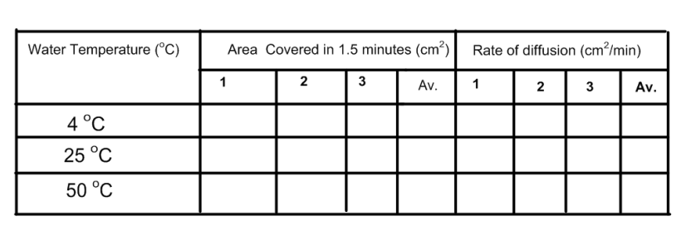
Draw a graph of your results

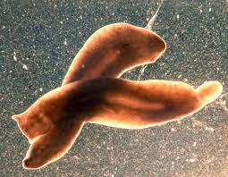

Questions:

- What did you find out about the relationship between the rate of diffusion and the temperature of the water?
- Can you explain your results using your knowledge of the particle model?
- Other than the temperature of the water, what other factors do you think would affect how quickly a substance diffuses in water?
- Can you use your results and your own knowledge to explain why, in very cold water, fresh-water flatworms are unable to get enough oxygen for respiration and therefore move very slowly?

Progress: further resources on particles are available here: http://www.thescienceteacher.co.uk/particles/

