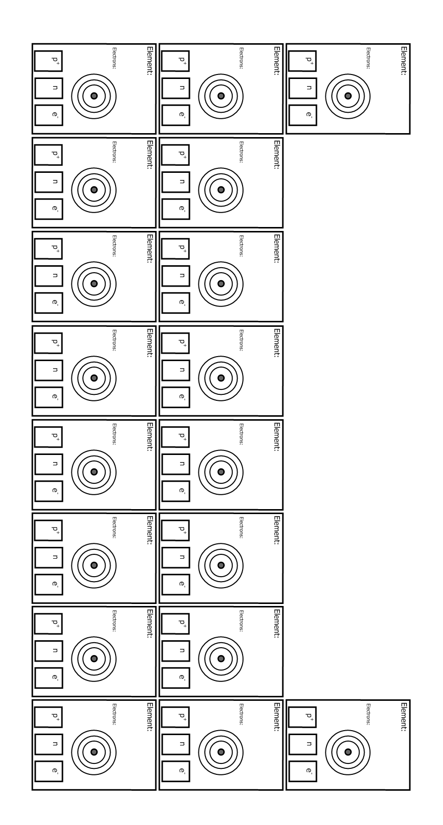

**2**

**What patterns do you see in how the elements are arranged?**

**4**

**He**

**Helium**

**PERIODIC TABLE OF THE ELEMENTS**

3

2

1

**ATOMIC NUMBER**

**ATOMIC MASS**

Electron Shells.

Fill up from the inner most shell first. Maximum of 2.

Then start new shell. Maximum of 8 on next 2 shells.

KEY: p+  = Number of protons

n0 = Number of neutrons

e- = Number of electrons