Topic | Control variables | Level | GCSE (or any course for students aged 11-16)
Outcomes | - To identify control variables from an experimental method  - To understand why we need to keep variables the same between experiments

The pollen count: how do they do it and why are variables controlled?

During July it’s peak season for pollen and with an estimated 31 million people suffering from hayfever, the pollen count is an important part of the weather forecast in the UK. But how do they work it out and how do they make sure that pollen counts carried out at different stations across the UK can be compared?

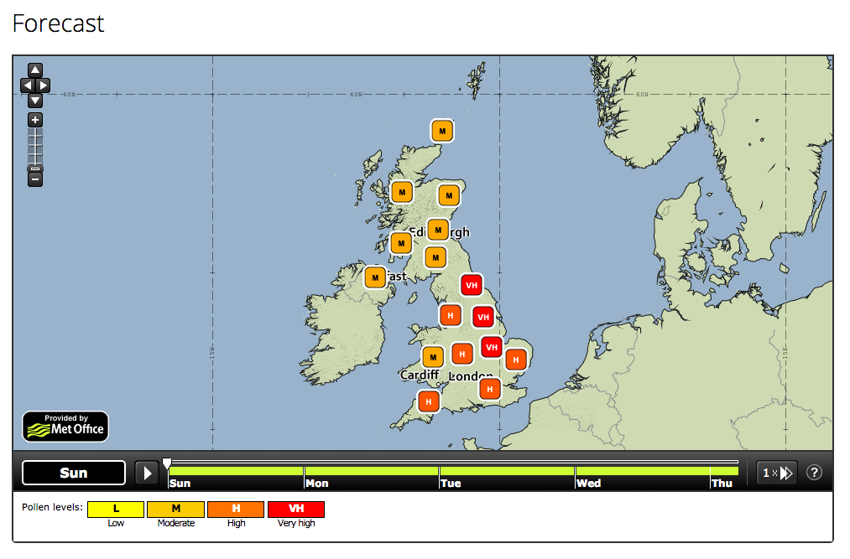
Figure 1 A pollen forecast of the UK. But how do we make sure that counts can be compared between each pollen station? Source: MetOffice

Questions

- Read the passage below about how pollen counts are measured. Write down a list of variables that must be controlled (i.e. kept the same) when pollen is counted at different pollen stations across the UK.
- For each of the control variables in your list, explain why this variable must be kept the same.
- What is the independent variable in these experiments?
- What is the dependent variable in these experiments?
- Why do you think that it has not been possible to get a machine to count the pollen?
How is the pollen count measured?
Taken and adapted from http://www.worc.ac.uk/discover/recording-the-pollen-count.html

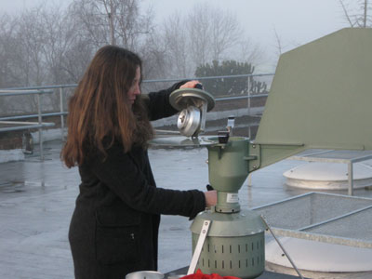
Our trap is located on the roof of the main University of Worcester building. The trap is located at this height to enable the general ambient airflow to be monitored which contains a good mix of the local and further distant pollen sources gathered on the wind. If the trap was at ground level then it would mainly collect pollen from the immediate vicinity.

The air is sucked into the trap through a slit at a rate of 10 litres per minute and the pollen and other particles are captured on a prepared sticky tape passing the slit at a set rate. The tape, after exposure to the air, is put onto a microscope slide and covered with a stain to aid identification and the pollen is then counted. Counting is done using a standard sampling procedure.

Twelve transects are counted across the width of the slide representing two hourly intervals. A daily total is obtained by adding the counts found in the twelve transects and these figures are then converted to grains per cubic metre of air using an equation. Counting each slide can take an hour or even longer depending on the amount of pollen on it. Nobody has yet developed a satisfactory automatic method for counting pollen.

The daily pollen count is an average of 24 hours. It is given as the number of pollen grains of one type (usually grass for the media) per cubic metre of air.
The trap samples air at 10 l/min through a critical orifice. The inlet is kept facing the airflow because the top part of the trap can move around, driven by the wind vane

Progress: further resources on how science works are available here: http://thescienceteacher.co.uk/how-science-works/

