Topic | Dynamic equilibrium | Level | GCSE and A Level (or any other course for students aged 14-18)
Outcomes | - To describe and explain what happens to a system at equilibrium using Le Chatelier's principle

Equilibria: making the perfect drink of coke

How do you like your Coca-Cola? With ice? With lemon? Below you are going to understand how to make the perfect fizzy drink using an understanding of equilibria.

Fizzy drinks are made by forcing carbon dioxide gas into the drink under high pressure. This process is called carbonation and causes CO₂(g) to dissolve in the drink to form CO₂(aq). Fizzy drinks ‘taste’ fizzy because of this dissolved carbon dioxide.

In an unopened bottle of coke the majority of the carbon dioxide molecules will be dissolved in the solution i.e. in the aqueous form.

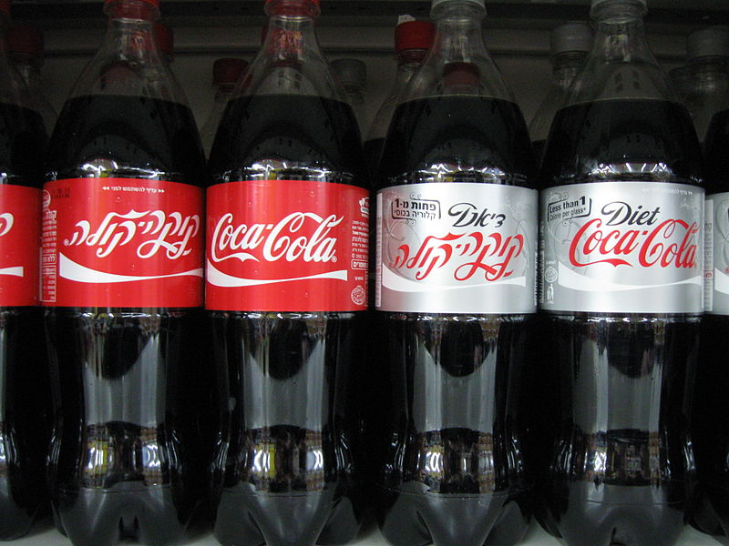

When carbon dioxide dissolves, the following four equilibria are established.

1 CO₂(g) ⇌ CO₂(aq)
2 CO₂(aq) + H₂O(l) ⇌ H₂CO₃(aq) (carbonic acid)
3 H₂CO₃(aq) ⇌ H⁺(aq) + HCO₃–(aq) (hydrogencarbonate ions)
4 HCO₃–(aq) ⇌ H⁺(aq) + CO₃^{2–}(aq) (carbonate ions)

Using your knowledge of equilibria, think through the questions below.

- When the bottle is closed, a dynamic equilibrium is reached. What can you say about the rate of the forward and reverse reactions?

- Can you predict and explain what will happen to the concentration of CO₂(aq) when the bottle is opened? Think about the pressure changes.

- Can you predict and explain what will happen to the pH of the coke when the bottle is opened?

- Can you use the equations above to suggest why adding a slice of lemon to your coke may cause it to taste slightly flat?

- Carbon dioxide is more soluble in cold solutions that warm solutions. Use this information to label each arrow below as either exothermic or endothermic.

CO₂(g)
CO₂(aq)

- Given enough time, a bottle of coke may go flat even if it was not opened. This is because the CO₂ molecules are small enough to pass through the microscopic holes in the plastic. Describe and explain what would happen to the pH of the bottle if this happened?

- Using what you have learnt, can you now describe and explain how you would make the perfect coke. Key terms to use in your answer:

Forward reaction, reverse reaction, endothermic, exothermic, pH, position of equilibrium, concentration, pressure,

Progress: further resources on equilibria are available here: http://www.thescienceteacher.co.uk/equilibria/

