Topic | Separating mixtures | Level | Key Stage 3 (or any course for students aged 11-14)
Outcomes | - To plan and carry out a method to separate salt from sand  - To select the correct apparatus for a practical

Salt and Sand

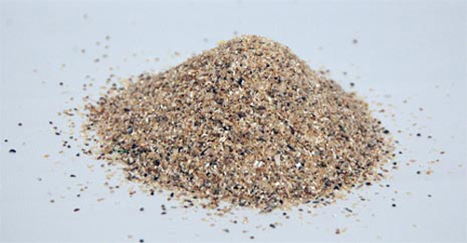

Each pair has been given a 5g mixture of sand and salt (3 grams of sand, 2 grams of salt). You have 45 minutes to obtain pure salt. The winner is the group with the highest yield of pure NaCl.

We will weigh each group’s yield of NaCl at the start of next lesson.

RULES
YOU CAN DEVISE YOUR OWN METHOD BUT…
YOU CAN ONLY USE THE FOLLOWING ITEMS

- Spatula
- Stirring rod
- Large beaker
- Filter paper
- Funnel
- Tap water
- Thermometer
- Conical flask
- Bunsen burner, tripod and gauze
- Petri dish
- Evaporating basin

Group Name | Mass of NaCl produced (g) | % Yield of NaCl | Comment on purity (e.g. colour)

Progress: further resources on separating techniques are available here: http://thescienceteacher.co.uk/separating-techniques/

