Topic | Fractional distillation of crude oil | Level | GCSE
Outcomes | - To be able to understand and use the words viscous, volatile, fraction and boiling point.  - To describe and explain how fractional distillation separates crude oil into different fractions.

Understanding the Language of Fractional Distillation

How easy it is for a substance to change into a gas.
A group of hydrocarbons extracted from crude oil that have very similar boiling points.
Compounds made up of hydrogen and carbon atoms only.
How difficult it is for a liquid to flow.
The temperature at which a substance changes from a liquid into a gas (also the temperature at which a substance turns from gas to liquid!!).
A naturally occurring mixture of hydrocarbons.
In pairs, discuss the words below and match to their correct definition.
Boiling point
Fraction
Crude Oil
Viscosity
Hydrocarbon
Volatility

Rearrange the following sentences to describe what happens during the fractional distillation of crude oil.

- Crude oil is heated until most of it evaporates and turns into gas.
- The crude oil is then separated into different fractions at different heights in the column. Each fraction contains hydrocarbons with similar boiling points.
- The evaporated crude oil enters the fractionating column.
- The gases rise in the column.
- When a substance reaches a height in the column where the temperature is equal to its boiling point, it condenses to form a liquid.

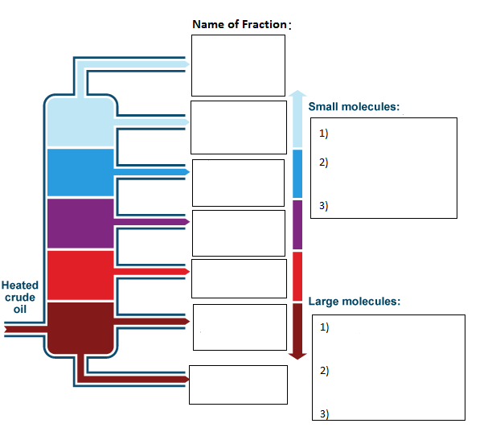

Fill in the labels on the diagram above using the words below.

Increasing viscosity - Decreasing viscosity – Petrol –
Refinery Gases - Fuel Oil - Decreasing volatility - Increasing volatility - Diesel – Bitumen - Lower boiling point - Higher boiling point -Bitumen – Kerosene

Complete the following table:

Hydrocarbon chain length | Position extracted from column (Top or bottom?) | Boiling Point °C  (High or Low?) | Viscosity  (High or Low?) | Volatility  (High or Low?)
Short (3-10)
Long (20-40)
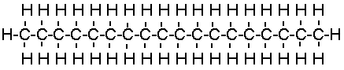

Now, using the words you have learnt, describe and explain how Bitumen is obtained from crude oil. Comment on its viscosity and volatility.

When the crude oil enters the fractionating column……

Progress: further resources on organic chemistry are available here: http://www.thescienceteacher.co.uk/organic/

