Topic | Labelling eukaryotic cells | Level | A Level (or any other course for students aged 16-18)
Outcomes | - To label the organelles found in a typical eukaryotic cell  - To consider how textbook diagrams of cells differ from electron micrographs and reality

Labelling the organelles of a eukaryotic cell

Sometimes it is difficult to make links between how cells appear under the microscope and how we represent them in textbooks. This is a really important skill for a biologist.

- Use the electron micrographs on the next page to label this eukaryotic cell.

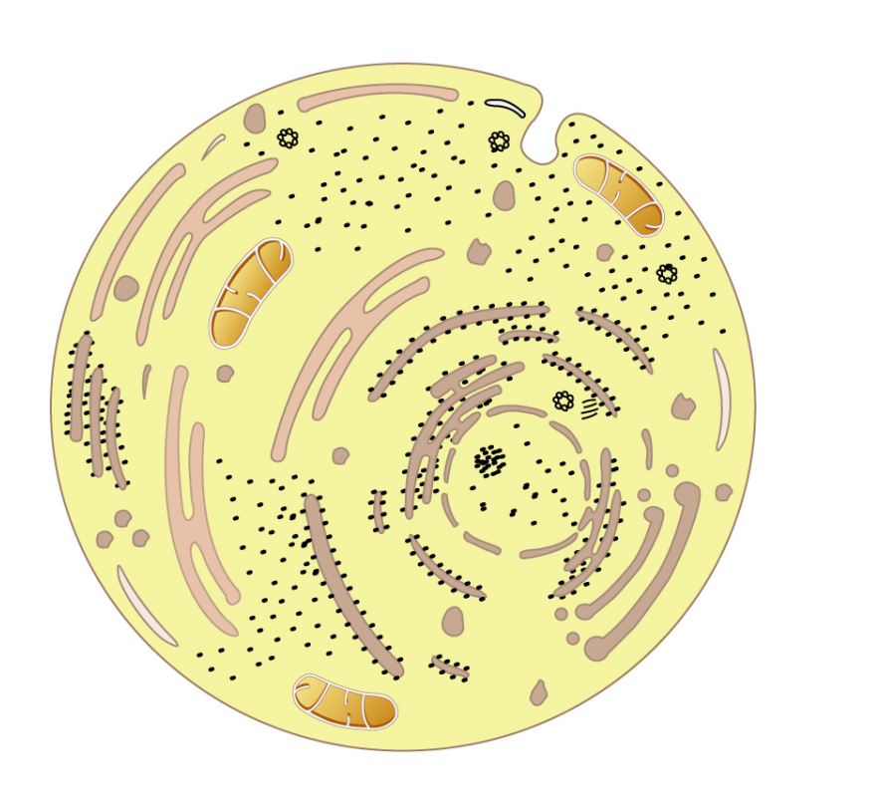
- Consider how accurate this textbook diagram is. How is it similar and different to the electron micrographs? Do you think the electron micrographs are accurate, and show what a cell really looks like?

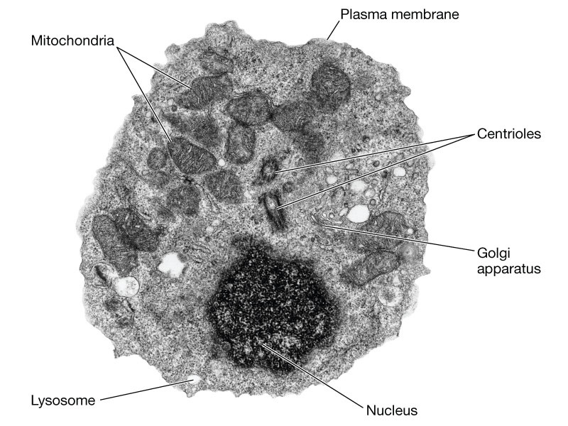

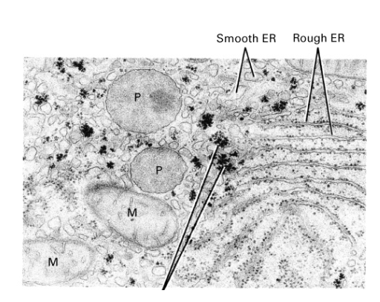

Progress: further resources on cells are available here: http://www.thescienceteacher.co.uk/cells/

