Topic | Rates of reaction | Level | GCSE
Outcomes | - To use a model to understand rates of reaction graphs at different temperatures and concentrations

How to understand rates of reaction graphs

Let’s imagine we want to measure the speed (rate) of a reaction when we add 1 gram of Mg powder to 50 cm³ of 0.5 mol/dm³ HCl.

Mg + 2HCl MgCl₂ + H₂

The easiest way to measure the rate of this reaction is to measure the volume of hydrogen gas produced using a gas syringe.
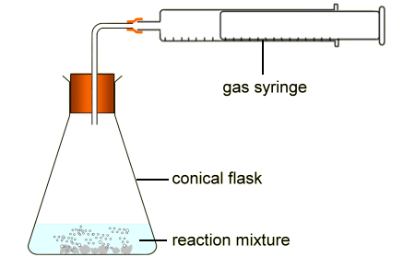

Figure1 taken from http://www.bbc.co.uk/schools/gcsebitesize/science/ocr_gateway_pre_2011/rocks_metals/7_faster_slower2.shtml

1. Can you sketch what you think the graph would look like if we add 1 gram of Mg powder to 50 cm³ of 0.5 mol/dm³ HCl at room temperature? Label this line A.

Time (s)
volume of gas (cm³)

2. Now, what would the graph look like if we repeated the experiment but at a higher temperature? Using a different colour pen, sketch on your graph what this would look like. Label this line B.

3. Finally, imagine you repeated the experiment at room temperature but instead used 50 cm³ of 1.0 mol/dm³ HCl. Can you sketch on your graph what this would look like. Label your line C.

Using a model to understand rates of reaction graphs

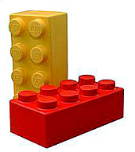
Models can help us to understand scientific ideas when we can’t actually see what is happening. Below is a model I saw used by Jill White to encourage students to think deeply about rates of reaction graphs.

We are going to use Lego bricks to model what is happening inside the conical flasks in the experiments above. Two people are going to see who can build a tower of Lego the quickest. There is only one rule: a yellow brick can only be placed on the tower if it is joined to a red brick.

Model | Model to investigate… | Person A | Person B | Time taken to build tower A (s) | Time taken to Build tower B (s) | Height of column A (cm) | Height of column B (cm)
1 | Looking at the effect of temperature on the rate | 10 yellow bricks  10 red bricks  Using both hands | 10 yellow bricks  10 red bricks  Using only one hand
2 | Looking at the effect of concentration on the rate | 15 yellow bricks  15 red bricks  Using both hands | 10 yellow bricks  10 red bricks  Using both hands
3 | Looking at the effect of concentration on the rate | 10 yellow bricks  20 red bricks  Using both hands | 10 yellow bricks  10 red bricks  Using both hands

Questions to help you understand the model:

- What did the bricks represent in this model?
- What did the height of the towers represent in this model?
- In model one, did person A or B represent the reaction at the higher temperature? Can you explain your answer?
- In model one, did the rates differ? What the does the model show you about the effect of temperature on the final amount of product produced?
- What does model two show you about the amount of product formed if we increase the amount of both reactants?
- What does model three show you about the amount of product formed if we increase the amount of only one reactant?
- Go back and look at your graph above. Do you still agree with your graph? Make improvements if you need to.

Progress: further resources on rates of reaction are available here: http://www.thescienceteacher.co.uk/rates-of-reaction/

