Topic | The Heart | Level | GCSE
Outcomes | - To label diagrams of the heart  - To evaluate different models of the heart

Models of the Heart

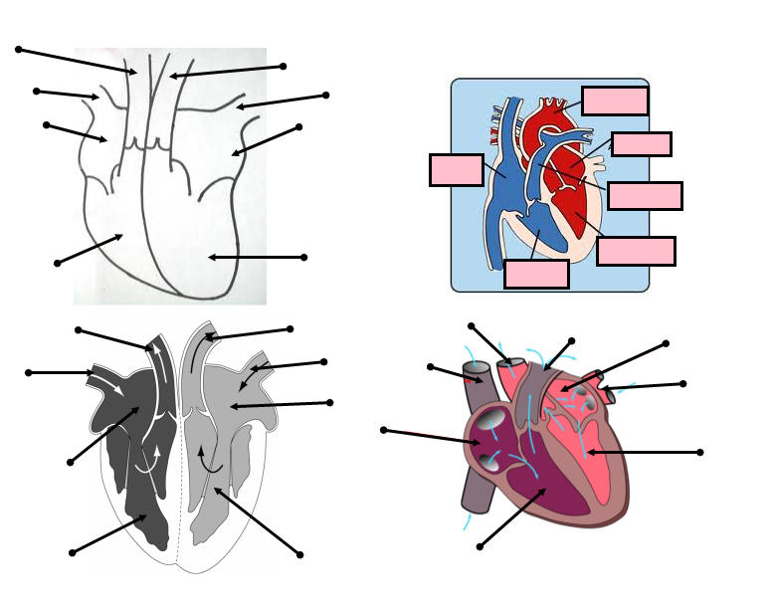

- Label each diagram of the heart
- How do the models differ?
- How are the models similar?
- Which model would be best for a heart surgeon? Explain your reasoning.
- Which model would you use to explain to a patient where the coronary artery is located? Explain your reasoning.
- Which model is most correct? Explain your answer.
- What are the limitations of these models?

Progress: further resources on biology are available here: http://www.thescienceteacher.co.uk/biology

