Topic | Evolution by natural selection | Level | GCSE
Outcomes | - To describe and explain the process of evolution by natural selection

Crossing the motorway: a tale of struggle for survival to help you understand the process of evolution by natural selection.

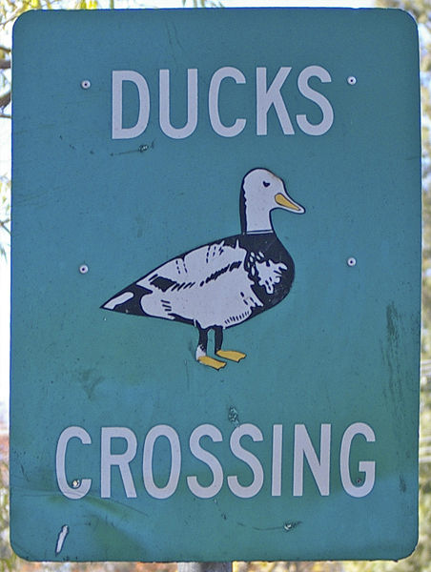

I'm going to tell you a sad but important story about a mother duck and her five ducklings.

Duckling number 1 was born with a limp due to a genetic mutation
Duckling number 2 was blind in one eye after a fight
Duckling number 3 was overweight because it ate too much food
Duckling number 4 was born with dark grey feathers
Duckling number 5 was born with white feathers

http://www.youtube.com/watch?v=hL1M5F0d_Kc. The mother duck and her five ducklings were living on a pond that was running out of water. They needed to move to a new pond that was just across a very busy motorway. This pond had lots of water and food. The mother duck and her five siblings began to cross the motorway together, but they soon got separated. When the mother duck reached the other side of the motorway, she looked down and could only find one of her ducklings. Sadly, the other four ducklings had died crossing the road.

- If only duckling number two had survived, what would happen to the number of one-eyed ducks in the pond over the next fifty years?

- The only duckling to survive was duckling number five. Can you provide a hypothesis to why this duckling survived and the others didn’t?

- Can you predict what would happen, over time, to the proportion of ducks in the pond with white feathers?

- Use the story above to prepare a five-minute presentation to explain the key features of evolution by natural selection; these are listed below. Use specific parts of the story to illustrate each point.

- There is a "struggle" to survive and reproduce
- Organisms show variation in characters that affect their success of surviving
- Parents possessing certain traits that enable them to survive and reproduce will produce more offspring than the other individuals in the population
- The population in the next generation will consist of a higher proportion of individuals that possess whatever adaptation enabled their parents to survive and reproduce (assuming the trait is caused by genes)
- Overtime the population will become adapted to the environment

- One of the drivers on the motorway saw the ducklings and shouted "Silly ducks, why can't they just adapt to build a tunnel under the motorway". Do you think this driver understands evolution? Explain your answer.

Progress: further resources on evolution are available here: http://www.thescienceteacher.co.uk/evolution/

