Topic | The development of the model of the atom | Level | GCSE (or any course for students aged 11-16)
Outcomes | To understand how the model of the atom has changed throughout history  To evaluate the strengths and limitations of a scientific model  To appreciate that scientific ideas change as a result of experimental evidence

Instructions for teachers – print page 2 in A3. The idea behind this activity is that students have to read the text about each atomic model and then use this information to draw a model of the atom at each key point along its development. Students will need an understanding of current atomic theory to evaluate the different models, so I think it is best if they have learnt atomic structure first. This is a great activity to help students appreciate that scientific thinking changes and that much of this evolution in thinking is driven by experimental evidence.

Who? | When? | What scientists thought and knew about the atom | Draw a labelled diagram to show what the proposed model of the atom would have looked like at that time in history | What was right about the model? | What was wrong about the model?
The ancient Greeks  e.g. Democritos | 400 B.C. | All matter could be divided and sub-divided into smaller and smaller units, and eventually there would be a tiny particle that could not be divided any further - an atom. Atoms were different shapes and sizes.
John Dalton | 1803 | Substances were made of atoms that were like tiny, hard spheres. Different substances were made of atoms that had a different mass.
Joseph John Thomson | 1897 | The atom was made up of tiny electrons. Because atoms have no overall charge they must also have positive charges to balance out the negatively charged electrons. Atoms where likened to a plumb pudding, with electrons (plumbs) embedded in a positively charged sphere (the pudding).
Ernest Rutherford | 1911 | There was a positive charge in the centre of the atom that was concentrated into a tiny spot called the nucleus. The nucleus is orbited by negative electrons.
Niels Bohr | 1914 | Electrons must orbit the nucleus at set distances in certain, fixed energy levels called shells. Not all electrons in an atom will have the same amount of energy as they exist in different shells at different distances from the nucleus.
James Chadwick | 1932 | There are neutral particles called neutrons in the nucleus of an atom. | 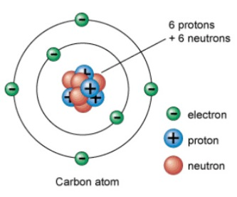
The development of the model of the atom

