Topic | Collision theory | Level | GCSE
Outcomes | - To use the collision theory to explain why changes to a reaction can increase the rate of reaction (temperature, concentration, surface area and catalyst)  - To understand why not all collisions are successful

The collision theory and rates of reaction

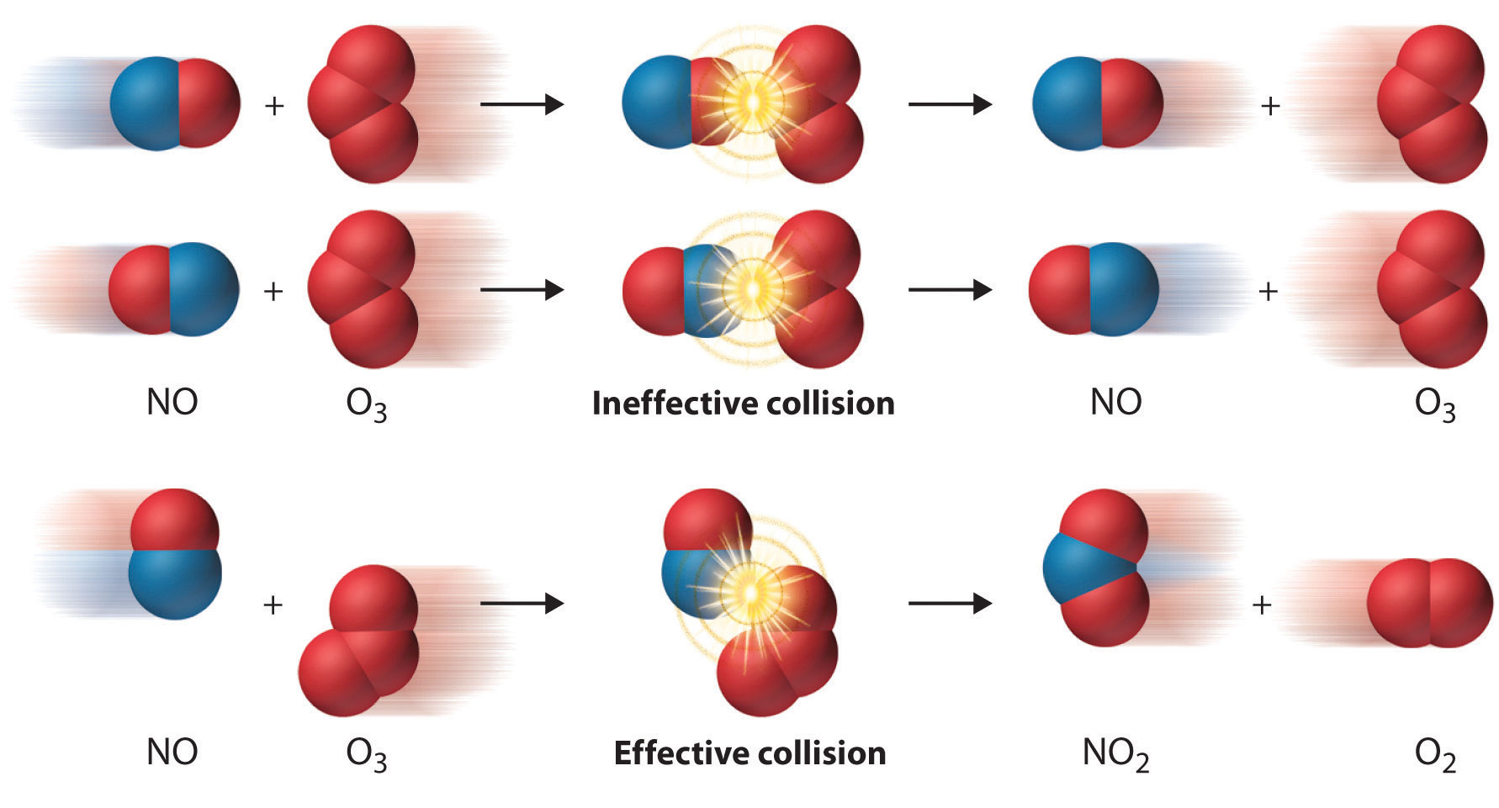

When two particles collide (hit each other) sometimes a chemical reaction happens. Not all collisions result in a chemical reaction. To increase the number of successful collisions we can change the conditions of a reaction (see page 2).

- Do all collisions between particles cause a reaction to happen?
- What do we call the minimum energy the particles must have for a reaction to happen?
- What do we call a collision between two particles that causes a chemical reaction?
- Look at the picture above, how do you know the first reaction is not a successful collision?

Change to the reaction | What happens to movement (kinetic energy) of the particles? | What happens to the frequency of collisions every second? | What happens to the number of successful collisions every second? | What happens to the rate of reaction?
Increase the temperature
Increase the concentration
Increase the surface area of a solid
Add a catalyst

Progress: further resources on rates of reaction are available here: http://www.thescienceteacher.co.uk/rates-of-reaction/

